jhe Official Publication of ALOA—An International Association of Security Professionals



Widely Publicized Master-Key Hacking Method  
Rattles the Security Industry

Inside: Experts weigh in on what's next Plus: Bare Bones AC, Videx CyberLock (part 3), Programming a Ford Transponder, Protectall Safe, History of the ALOA Open and more

Keep Your Day Job

Come to Las Vegas and invest in your future as a security professional.

Discover classes, workshops, and exhibits that will keep you competitive in today’s marketplace.  
Las Vegas Hilton/Las Vegas Convention Center • July 14-20, 2003

The only gamble is staying home,



***Producti***

***far***

**LOCKSMITH Professionals**

**AD / ID KEY TAGS**

Specifically designed to identify the product you work with daily and promote your business with your custom Ad copy.

|  |  |
| --- | --- |
| back side of tag with 4 lines for key identificatior  KEYS FOR | 1 |
| v ■ |
| KJ |
| SANZO- ENOCOTT. NY 13760 |
|  |  |

**Clear Plastic Protective Sleeves** Stock# PPS10

Protect your key tags with * 100 200 500 1000

durable plastic sleeves 11.50 19.95 42.00 68.50

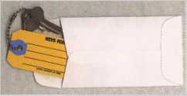

**Key Tag Envelopes**

**TO ORDER:** Choose QTY., Key Tags with Chains or Rings, TAG COLOR and Provide Imprint Copy (printed black only).

ANDOVER LOCK & KEY SERVICE

3221 LAKESIDE HWY.  
ANDOVER MA 05242  
(508) 626-1111

**FREE Printing of Your Ad Copy on bac**

- wd—

LAKEVIEW

LOCKSMITH

24 Hour Service (845) 556-LOCK

**Choose from Brass Plated Bead Chains or Chrome Plated Wire Rings**

Stock # KTE3 Actual Size: 2Vfe" x 4V4n Added security and finishing touch when presenting keys to your customers

* 100 200 500 1000

10.50 17.00 37.50 65.00

QUANTITIES100 200 500 1000 2000 3000 5000

itKEY TAGS with CHAINS or RINGS 32.00 42.95 83.95 115.00 195.00 269.00 395.00

YOUR CHOICE OF CHAINS OR RINGS - IF NOT SPECIFIED WE SHIP CHAINS

**Key Tags Only (no chains or rings)** - Deduct 10% from above prices National Logos - No Charge / Custom Logos - Add $25.00 and supply clean B & W artwork

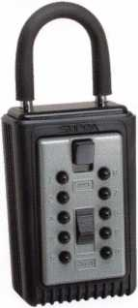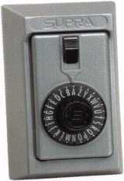

**COMBINATION KEY BOXES**

©SUPRA

**ALL METAL**

**PROFESSIONAL**

CLnfif

*Wrnmmmmm®*

Key Storage Lock Box

* ALL METAL Construction
* Great Economical Pricing

t/Simple to set/ Simple to open

* 5 Year Warranty

**DIAL**

1-4 36.95 EA. / 5-9 33.95 10 or MORE 30.95 EA.

**PUSHBUTTON**

1-4 37.95 EA. / 5-9 34.95 EA.  
10 or MORE 31.95 EA.

**Set your own combination**

The combination can be changed in seconds — without special tools or disassembly. Changing the shackle combination also automatically changes the combination for the sliding key storage door.

**SERIES LOCK BOXES**

Both models now have weather resistant  
ALL TITANIUM METAL CONSTRUCTION  
with metal back and buttons. Both models  
are also available with PUSH BUTTON  
COMBINA TION LOCKS that are easy to  
set & reset.

Stock #S5-DIAL Surface Mount Unit

No Home Should Be Without One  
The Surface-Mount S-5 Supra  
Lockbox is a product you can provide to  
any homeowner, easily priced to your  
customer in the $50.00 range installed  
(simple 4 screw installation). Carry one

with you at all times to demonstrate - stock # S5-PUSHBUTTON  
once shown it sells itself I! Surface Mount Unit

ShurLok has designed an all-metal key storage box that is the safest, most secure lock box on the market. Separate easy to set combinations open the shackle and key compartment — and the combinations can be changed in seconds. The ShurLok is so simple to use a child can open it, yet so versatile it will satisfy the Real Estate professional or anyone requiring key access in a lock box. Unique double combination allows all users access to key(s) while allowing only authorized users access to the shackle and will prevent lock box removal or theft.

Stock # C3-PUSHBUTTON

Removable KeyBox, DoorGuar rubber bumper protects surfaces

Stock #C3-DIAL  
Removable KeyBox  
DoorGuard rubber bumper protects surfaces

**1 to 9 $19.95 ea.**

**10 or more $17.95 ea.**

*if color is not specified we ship blue*

Stock #SLK100R

Brick Red

change

button

|  |  |  |
| --- | --- | --- |
| llciiii) |  |  |
| 1 ) |  | -Q. |

**10,000**

**Combinations**

**Possible!**

Changing the combination

for the shackle

only takes a few seconds

with a simple turn  
of the change button.

Stock #SLK100  
Blue

**\*$7.00 SHIPPING CHARGE ADDED PER ORDER** NY RESIDENTS ADD APPLICABLE SALES TAX

**SANZO SPECIALTIES, INC. TOLL FREE: 1-800-222-4041**

**BOX 68 ENDICOTT, NY 13760 FAX: 607-748-0507**



***VISA***



NOVUS|

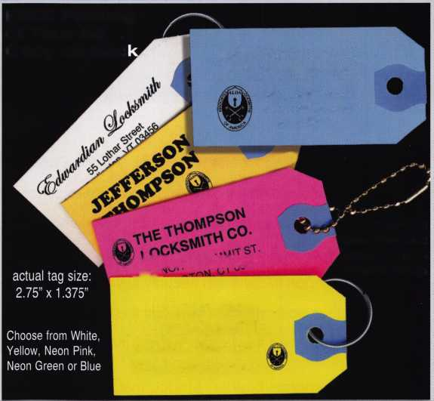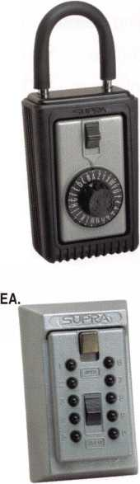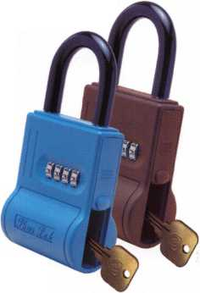

**president**

journey

i

s

Controlling Access is the "key." What is intended to be a pun is looking into our industry and controlling the future. Today's issues concerning security are more about knowing who was where - and when - than about who has the key. Keeping a record of when a door is opened, and by whom, is more important than knowing about the key. Five years ago,

I began to call High Security keys standard keys. I believed that they were so much better than non-controlled keys that they should become the minimal standard. Now today, I am convinced that by themselves, they are not enough.

Corporate business has too much to risk. They are compelled to provide security for their employees as well as their property. The issue of personnel security has driven much of this need to know. Litigations have left many companies liable for damages based on a lack of security measures. Life safety codes leave some openings in vulnerable positions. These concerns accelerate the necessity for access control.

Cause and effect have made a mark, changing the issues concerning security. Our indus­try should be a huge part of controlling this change. Professional locksmiths are part of an industry positioned to provide this next level of security. ALOA will have classes on Access Control this July in Las Vegas. Plan to attend.

See you next month,  
Randy Simpson, CML

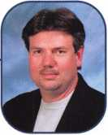

Keynotes • March 2003

f

e

a



res

Cover Story

10

**So (Now) What?** Widely Publicized Master-Key

Hacking Method Rattles the Security Industry **Report by Jim DeSimone, Keynotes Editor**

When the New York Times recently ran a story reporting the master key hacker findings of an AT&T researcher (and that story was picked up by several other major media, including USA Today), reactions from within the locksmith indus­try ranged from one end of the emotional spectrum to the other. But the com­mon denominator to all knowledgeable parties involved was a collective,

"Who cares?" ALOA explores whats next.

Access Control

**14**

The Bare Bones of Access Control **bx Greg Perry, cml,cps**

It's a shame that we're this far into the electronic access control revolution in our industry, and there is still a vast army of locksmiths who either haven't taken the electronic plunge, or who are, at the very least, timid about their command of access control applications, products, and servicing/installation techniques. Lets start with the basics.

**18**

Videx - Cyberlock, Part 3 **By Sal Dulcamaro, CML**

In this final part of this article series, we will deal with CyberLock interchange­able cores, CyberKeys, and programming and auditing of the system.

Automotive:

22

**24**

Ford Tough: Harley F-150 Sports

**Transponders Part 2** By Jeff Trepanier, RL

Using the NGS, we go step-by-step through the process of programming the transponder.

**The Ford Fiasco** ByEncA. costiey, ***crl***

No, you won't see this one driving up into your shop parking lot. Even so, it may take you for a bumpy ride! Many locksmiths have choice words for describing Ford products, and most of them can't be repeated here. Well, here's yet another Ford to describe with flowery adjectives, and FHenry Ford had nothing to do with it! In my 20-plus years as a locksmith, I've seen only two of the old Ford penny gumball machines.

Safes:

**28**

**32**

Safes: A Protectall ... From Who? **By Greg Perry, CML, CPS**

"Can you open an old safe, and how much?" they asked. I said, "Of course, but I'll need a little more info before pricing the opening." I stopped by to look at the safe and take a couple of pictures with my digital camera. The safe was a Protectall fire safe. The first Protectall fire safe I've seen in person. We set the opening time for a week later.

**History of the ALOA Open** By Reg Moxley, CPL, co-chairman of the ALOA Open

It started humbly, but grew and grew and grew. Today, your ALOA Open Golf Tournament, now in its 1 8th year, has generated over $200,000 to the great cause of ALOA scholarships for aspiring and needy locksmiths. Bring your clubs to Las Vegas and help us keep the tradition going strong.

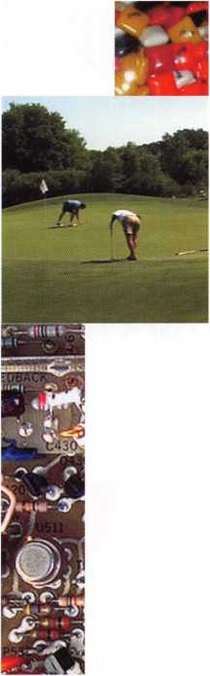

|  |  |  |
| --- | --- | --- |
| Executive .... | 5 |  |
| Applicants.. | 6 | c |
| Calendar.... | 8 | a> |
| Legislative |  | E |
| Update | ...36 |  |
| Core | ...39 | L. |
| Classifieds . | ...40 | 0 |
| Associate |  | Q. |
| Members | ...42 | a> |
| Back Page . | 44 | "O |

**Visit our website at [www.aloa.org](http://www.aloa.org)**



*wm*

***Visit our Website on  
www. stamcctv. com***

**THE COMPLETE**

**CCTV PROGRAM ON CD-ROM  
FOR STAFF TRAINING AND**

**PRODUCTIVITY ENHANCEMENT**

STAM Insight has been  
developed to enhance CCTV  
skills and productivity with  
many different uses.

Productivity

System Drawing t# Estimation CCTV Training U CCTV Reference w Sales/Demo **W** System Design t# Staff Evaluation

14 fmm

CCTV Content

CCTV Calculators

Demonstration Tool

Estimation

Drawing

Internet Enabled

WORKMATE

ULTIMATE

Pre-Test

Quizzes

Knowledge Assessment

**Sold in Over 50 Countries**

Distributed by:

3003 Live Oak Street  
Dallas,Texas 75204

COPYRIGHT © 1996 Security Training and Marketing Pty Ltd. All rights reserved ACN 057 006 541



■ Yes, please send me a FREE PREVIEW CD ROM $9.95 S/H

Name:

Job Title:

Organization:

Address:

Country Tel: (

.Zip/Postcode,  
e-mail

Fax: ( )

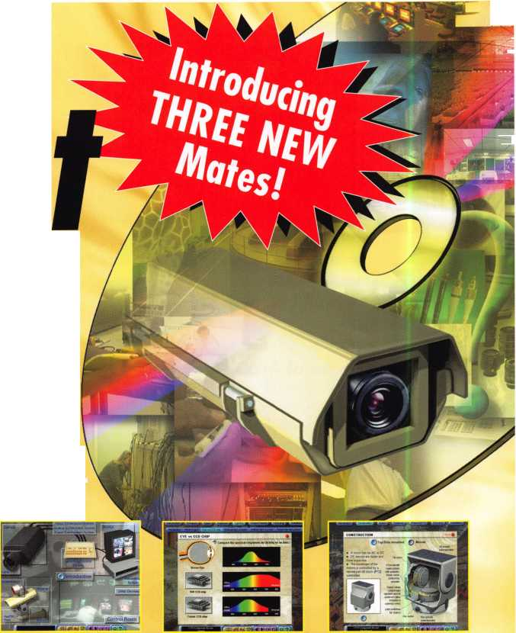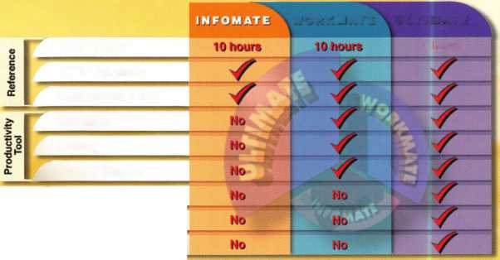

**executive**

Volume 49, Issue 3



Additional contact information for the ALOA Board and most Keynotes authors is  
available through "Locksmith Search'" on the ALOA Web site- [www.aloa.org](http://www.aloa.org) or by  
contacting the ALOA office at 3003 Live Oak Street; Dallas, TX 75204; (800)532-2562;  
FAX (214)827-1810; e-mail [aloa@aloa.org](mailto:aloa@aloa.org).

|  |  |
| --- | --- |
| Editor  Jim DeSimone | . ...[editor@aloa.org](mailto:editor@aloa.org) |
| Technical Editor  David Lowell, CML, CMST .... | [david@aloa.org](mailto:david@aloa.org) |
| Editorial Advisor  John D. Cannon, CML | .[jdcannon@worldnet.att.net](mailto:jdcannon@worldnet.att.net) |
| Art Director  Betty Henderson | [betty@aloa.org](mailto:betty@aloa.org) |
| Advertising Sales  Kim Hammond | voice: 817-645-6778  Fax: 817-645-7599 e-mail: [adsales@aloa.org](mailto:adsales@aloa.org) |
| Executive Director  Charles W. Gibson, Jr., CAE | [charlie@aloa.org](mailto:charlie@aloa.org) |
| Convention & Meetings Manager  Jo Anne Mims [Joanne@aloa.org](mailto:Joanne@aloa.org) | |

PRP/Education Manager

David Lowell, CML, CMST [david@aloa.org](mailto:david@aloa.org)

Operations/Membership Manager

Mary May [mary@aloa.org](mailto:mary@aloa.org)

Director of Public Policy

Tim McMullen, CAE [tim@aloa.org](mailto:tim@aloa.org)

IT Operations Manager

Greg Jackson [greg@aloa.org](mailto:greg@aloa.org)

Comptroller Kathy J. Romo

Membership Coordinator Shelly Jett

Convention & Meetings Assistant Karen Lyons

PRP/Education Coordinator Janelle Ramirez

Accounting Coordinator Stephanie Brothers

Mail Room Coordinator Kevin Wesley

Receptionist Shawn Alvear

Contributors

Jerome Andrews, CML  
Paul Chandler, CRL  
Claire Cohen, CML  
Brian Costley, CML, CMST  
Ray D'Adamo, CML

Sal Dulcamaro, CML Billy Edwards, CML Dan Graffeo, CRL,CMST AJ. Hoffman, CML Jeff Nunberg, CML, CMST

Mike Oehlert, CPL, CPS Randy Simpson, CML Robert Stafford, CML Dave Thielen, CML Greg Perry, CML,CPS

Tom Seroogy Charles Stephenson, CPS Dennis Watanabe, CML, CMST

Mission Statement: The Associated Locksmiths of America, Inc. is dedicated to enhancing the professionalism, education and ethics among locksmiths and those in related sectors of the physical security industry. With approximately 10,000 members in the United States, Canada and the freeworld, ALOA is poised to help members obtain the knowledge, the strength, and the confidence to perform their role in the physical security field with pride and dignity. But it is only through active involvement and participation that ALOA can fully achieve its potential—and can help members to achieve theirs.

Policies: **Keynotes**® is the official publication of the Associated Locksmiths of America, Inc. (ALOA). **Keynotes**® acts as a moderator without approving, disapproving, or guaranteeing the validity or accuracy of any data, claim, or opinion appearing under a byline or obtained or quoted from an acknowl­edged source. The opinions expressed by the authors do not necessarily reflect the official views of ALOA. Also, appearance of advertisements and new products or service information does not constitute an endorsement of products or services featured by the Association. The Association does not accept responsibility for the inaccuracy of any data, claim, or opinion appearing in this publication, due to typographical errors on the part of the authors, Association staff or its agents.

Editor's Note: This publication is designed to provide accurate and authoritative information in regard to the subject matter covered. It is provided and disseminated with the understanding that the publisher is not engaged in rendering legal or other professional services. If legal advice and other expert assistance is required, the services of a competent professional should be sought.

Authors' Payment: Payment for eligible submissions to Keynotes will be based on the following criteria: topic, time spent and past contributions. Authors who regularly submit to **Keynotes**® are generally paid a higher rate. The latter is especially true of authors who write to fit specific editorial needs and submit said copy by **Keynotes®** deadlines. As a general guideline: Average payment for a 750 word, business or light' technical article would be $200. Payment for a 1500 word article involving significantly higher time and research efforts would be $400.

Payment will not be offered for articles submitted by ALOA employees or members of the ALOA Board of Directors (unless material is of a technical nature), nor for articles submitted by a company that promote that company's products or services. ALOA reserves the right not to pay for articles sub­mitted by an individual(s) that promote a particular company's products or services.

Disclaimer: The Associated Locksmiths of America, Inc., (ALOA), reserves the right to refuse any article for any reason. Additionally, ALOA reserves the right to edit, amend or modify any article submitted for publication in order to preserve technical accuracy, clarity, fairness or grammatical cor­rectness. ALOA will make the best efforts to notify the author of any changes. The extent of ALOA's liability for any article or information contained therein will be a notice of correction or retraction in the next possible issue.

**Keynotes®** (ISSN 0277 0792) is published monthly except for the combined June/July issue by The Associated Locksmiths of America, Inc., 3003 Live Oak St., Dallas, TX 75204-6186. Telephone: (214) 827-1701; FAX (214) 827-1810; e-mail [aloa@aloa.org](mailto:aloa@aloa.org). Subscription rates for members—$15.00 per year. Second class postage paid at Dallas, Texas. POSTMASTER: Send address changes to: Keynotes, 3003 Live Oak St., Dallas, TX 75204-6186. © Copyright 2003, All rights reserved. No part of the contents may be reproduced or reprinted in any form without prior written permission of the publisher.

President

Randy Simpson, CML (713) 780-7026 [president@aloa.org](mailto:president@aloa.org)

Secretary

John D. Cannon, CML (703) 960-6413 [secretary@aloa.org](mailto:secretary@aloa.org)

Directors, Northeast

Robert E. Mock  
(215)624-5035  
[nedirector@aloa.org](mailto:nedirector@aloa.org)

Peter Sarailian, CRL  
(973)890-9797  
nedirector@aloa. org

Wiiliam L. Young, CML  
(610) 647-5042  
[nedirector@aloa.org](mailto:nedirector@aloa.org)

Directors, Southeast

Vincent Formon, CML, CPS  
(901)324-2910  
[sedirector@aloa.org](mailto:sedirector@aloa.org)

Donald E. Rule, CML  
(662) 324-2658  
[sedirector@aloa.org](mailto:sedirector@aloa.org)

Directors, North Central

Mark E. Blum, CML, CPS  
(517) 482-5809  
ncd i rector@a loa. org

John Soderland, CML, CMST  
(414) 327-5625  
prolock@aloa. com

Director, South Central

CD Lipscomb, CML, CPS  
(903)874-3522  
scd i rector@a loa. org

Directors, Southwest

Gordon R. Racine, CML  
(719) 384-4707  
[swdirector@aloa.org](mailto:swdirector@aloa.org)

Julie McCluney, CRL

(714) 636-5652  
[swdirector@aloa.org](mailto:swdirector@aloa.org)

Director, Northwest

Scott L. Henke, CPL, CPS  
(907) 248-3785  
[nwdireetor@aloa.org](mailto:nwdireetor@aloa.org)

Director, European

Hans Mejlshede, CML  
(453)539-3939  
[eurdirector@aloa.org](mailto:eurdirector@aloa.org)

Director, Asian

JoeJ. Lee, CRL  
(215)289-2404  
[asiandirector@aloa.org](mailto:asiandirector@aloa.org)

Director, Associate

Paul M. Justen  
(800)333-6953  
a sd i rector@a loa. org

Trustees

[trustees@aloa.org](mailto:trustees@aloa.org)

John j. Greenan, CML, CPS  
(773) 486.2030

Dallas Brooks  
(334) 826-8990

David M. Lowell, CML, CMST  
(800) 532-2562

Past Presidents

1999-2001 John Greenan, CML, CPS  
1997-1999 Dallas C. Brooks  
1995-1997 David Lowell, CML, CMST  
1993-1995 Breck Camp, CML  
1991-1993 Henry Printz, CML  
1989-1991 Evelyn Wersonick, CML, CPS  
1987-1989 Leonard Passareilo, CPL  
1985-1987 Joe Jackman, CML  
1983-1985 Stanley Haney, CPL  
1981-1983 Louis LaGreco, CPL  
1979-1981 John Kerr, RL  
1977-1979 Clifford Cox, CML  
1974-1977 Charles Hetherington  
1972-1974 Gene Laughridge  
1970-1972 William Dutcher, RL  
1968-1970 Constant Maffey, RL  
1966-1968 Harold Edelstein, RL  
1964-1966 William Meacham  
1962-1964 Robert Rackliffe, CPL  
1960-1962 Edwin Toepfer, RL  
1956-1960 Ernest Johannesen



Keynotes • March 2003

AL

MD

NM

Hilliard

Wetumpka

Melanie Pearson

AZ

Glendale

Scott Monaghan

Phoenix

Scott D. Anderson

Sponsor: Alan N. Anderson

*CA*

Anaheim

Alan R. Elson

Sponsor: Daniel S. Enriquez CRL Imperial Beach

William J. Long

Sponsor: Jay E. Long

San Leandro

Esmeralda Rodas

Sponsor: Gerardo A. Rodas

CO

Edwards Randy Hosier

Sponsor: Kevin R. Silvers CML

Evans

Curt E. Burton

Sponsor: John L Shandy CML

FL

Orlando

John D. Wild

Sponsor: Johnnie D. Mills CRL

Bristol

Patricia M. DuBovi

Sponsor: William T. Beranek

Chicago

Karl D. Barnes

Chicago Heights

Seretse Robinson-Perry

Sponsor: Vincent Glispie CRL

Troy

James R. Criswell

IN

Chesterton

Jeffery A. Guth

Sponsor: Vincent Glispie CRL

KS

McPherson Steven Becker

Sponsor: Gordon R. Racine CML

Overland Park

Joseph E. Buckingham

Nicholasville

Jerry A. Morgan

Sponsor: Thomas J. Loyal

MA

Salem

Robert Auch

Sponsor: John R. Whitmarsh CPL Worcester

Arthur Smick

Mechanicsville

Charlie Willett

Sponsor: Brooke P. Berry CRL

Ml

Dearborn Heights

Christopher A. Bak CRL

Sponsor: Michael F. Cutler CML

Detroit

Larry Walker

MN

Burnsville

Richard Morningstar

Sponsor: Dana L. Lee CML

Ham Lake John Kleinschmidt

Sponsor: Mark W. Lundblad CML, CPS

MO

Jefferson City

Brandon M. Bock

Sponsor: P Kevin Hunton CML

NH

Nashua

Martin G. Russo

Sponsor: Michael F. Perkins

Rindge

Erik Nelson

Sponsor: John F Weir

Albuquerque

Max Blea

Sponsor: Frank E. Hester Las Cruces

Mike J. Madrid

Sponsor: Gordon R. Racine CML

Los Lunas

Robert T. Bollman

Sponsor: Brian J. Sweeney CML

NV

Cal Nev Ari

RoseMarie Swaney

Sponsor: Eugene R. Altobella Sr

Henderson

Dennis R. Allen

Sponsor: Eugene R. Altobella Jr

Las Vegas

Richard Marrero Tim J. Juleff

Sponsor: Eugene R. Altobella Jr

Stephen E. Lowery

Sponsor: Eugene R. Altobella Jr

Pahrump Bill K. Walker

Sponsor: Eugene R. Altobella Jr

Newburgh

Gary B. White

OH

Dublin

Donald L Abrams

Sponsor: Robert D. Stegmeier

Dewey A. Shearer

Sponsor: Timothy J. Moore CRL

Plain City

Adam K. Dawson

Sponsor: Timothy J. Moore CRL

Timothy J. Moore Jr

Sponsor: Timothy J. Moore CRL

Thomas B. McDowell

Sponsor: Timothy J. Moore CRL

Jerry T. Thompson

Sponsor: Timothy J. Moore CRL

Gregg A. Rochotte CRL

Sponsor: Peter M. Ballotta CML CPS

Sponsor: Timothy J. Moore CRL Somerset

Gregory L. Machmer

Sponsor: Timothy J. Moore CRL

PA

Skippack

Francis G. Huguenin

Sponsor: John L Perla

TX

Fort Worth John Wynn CRL

Sponsor: Joseph H. East Jr

Granbury Wesley Holmes

Sponsor: Michael R. Harrison

VA

Alexandria

Tim Indart Tahir Muneer

These applicants are scheduled for clearance as members of ALOA. The names are published for member review and comment within  
30 days of this Keynotes issue date, respectively, to ensure applicants meet standards of ALOA's Code of Ethics. Protests, if any, should  
be addressed to the Membership Department and must be signed. Active Membership applicants (a) have worked in the industry two or  
more years. Allied Membership (AL) applicants are not locksmiths, but work in a security-related field. Apprentice Membership (AP)

applicants have worked in the industry less than two years.

Keynotes • March 2003

VT

South Burlington John Fitzpatrick

Sponsor: Andrew A. Edmunds CPL, CPS

WA

Yakima

Andrew Taylor

Sponsor: Kevin Leadon

WV

Clarksburg

Steven McIntyre

Sponsor: Ronald D. DeVall CRL

Martinsburg

Susan Voorhees Walter McCarthy

Australia

Brisbane Queensland

John L McLeay

Canada

Toronto

John F. Smethurst

Sponsor: Wendy E. Passarello RL

Denmark

Copenhagen Valby

Erik Rasch

Sponsor: Hans Me/lshede CML

d

London

Mark Layman

Sponsor: Ken Dale

France

Les Ponts-De-CE

Pierre Madelin

Hksar

Ka Nam Arri Wong

*Tsing*

Chi Hung Kwok

Japan

Higashi Yatushiro-g

Takumi Wa tana be

Sponsor: Yuriko Yanai

Kasukabe Saitama

Tomohiko Okuyama

Sponsor: Yuriko Yanai



Penang Butterworth

Han GoeyChee United Kingdom

Ware Hertfordshire Matt Worboys

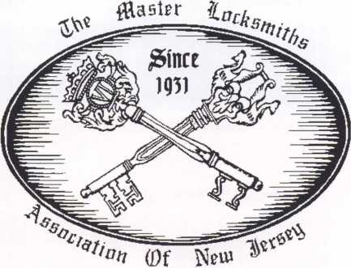

MLANJ 2003  
Annual Convention

(Classes, Trade Show, and Banquet)

April 2nd thru April 6th

Somerset, New Jersey

For More Information:

PO Box 2441

Morristown, NJ 07962-2441  
Fax 973-538-1588

Or visit our web site at  
[www.MLANJ.org](http://www.MLANJ.org)

Keynotes • March 2003

**MAY I APR MAR**

**upcoming**

|  |  |
| --- | --- |
| 5 Ohio Valley Chapter of ALOA  Membership Meeting 7pm  Ryan's Steak House  Middletown, OH (off exit 32) Mehdi Zahedi (937) 294-4241 | 10 Greater Dallas Locksmith Assoc. 11 Greater Houston Locksmith Assoc 14-15 Lous-Miss Spring Conference  Membership Meeting 7:30pm Membership Meeting 7:30pm Holiday Inn • Hammond, LA  Han Johnsen Company Judy Clifford (979) 297-2413 Lee Holcomb, CRL  Landy Dyess (972) 682-0505 <http://ghla.lcis.com/index.html> 601-798-402019 |
| 25 San Diego Chapter of ALOA/Cb Membership Meeting 6:30pm Linda Vista Village Clubhouse 2750 Wheatstone St., San Dieg Mike Perry (858) 967-9761 | 26 Pacific Locksmith Association  Membership Meeting 6:30pm  Denny's Restaurant Tualatin, OR  Dan Cunningham 360-835-1191 [www.pla-pro.org](http://www.pla-pro.org) |
| 2 Ohio Valley Chapter of ALOA  Membership Meeting 7pm  Ryan's Steak House  Middletown, OH (off exit 32) Mehdi Zahedi (937) 294-4241 | 8 Greater Houston Locksmith Assoc 14 Greater Dallas Locksmith Assoc. 16 Central Florida Locksmith Assoc.  Membership Meeting 7:30pm Membership Meeting 7:30pm Membership Meeting 7:30pm  Judy Clifford (979) 297-2413 Han Johnsen Company Orlando, FL • Jim Riley  <http://ghla.lcis.com/index.html> Landy Dyess (972) 682-0505 (863) 294-8679 |
| 29 San Diego Chapter of ALOA/Cb Membership Meeting 6:30pm Linda Vista Village Clubhouse 2750 Wheatstone St., San Dieg Mike Perry (858) 967-9761 | \ 29-3 Security Hardware Distributors  Assoc. Annual Membership Conf.  Ponte Verde Beach, FL  Talbot Gee 215-564-3484 [www.shda.org](http://www.shda.org) |
|  | |
| 3 California Locksmiths Assoc.  Trade Show and Education Ontario Convention Center Suzanne Harmony 714-632-6800 (see ad pg 31) | 7 Ohio Valley Chapter of ALOA 27 San Diego Chapter of ALOA/CLA 28 Pacific Locksmith Association  Membership Meeting 7pm Membership Meeting 6:30pm Membership Meeting 6:30pm  Ryan's Steak House Linda Vista Village Clubhouse Denny's Restaurant Tualatin, OR  Middletown, OH (off exit 32) 2750 Wheatstone St., San Diego Dan Cunningham 360-835-1191  Mehdi Zahedi (937) 294-4241 Mike Perry (858) 967-9761 [www.pla-pro.org](http://www.pla-pro.org) |
|  | |

|  |  |  |  |
| --- | --- | --- | --- |
| UPCOMING PRP SITTINGS | | 5/16/2003 | 6:00PM • St. Charles, MO  Bi-State Chapter |
| 3/2/2003 | 8:00 AM • Maplewood, MN |  | Kenneth Kim, CPL 314/351-7252 |
|  | MN Chapter of ALOA  Dana Lee, CML 612/968-4500 | 5/17/2003 | 5:00PM • Seattle, WA  KDL Hardware Supply, Inc. |
| 3/12/2003 | 8:00AM • Dallas, TX • ALOA  Janelle Ramirez 800/532-2562 X30 |  | Julie Pilgrim800/926-7716 or 206/682-7383 |
| 3/15/2003 | 10:00AM • Chamblee, GA  GA Chapter of ALOA  John C. Elliott, Jr.,CML,CPS 770/ | 6/1/2003 | 8:30AM • Lewistown, MT  Montana Chapter of ALOA  Michael Alexander 406/549-5625 |
|  | 314-7859 | 6/12/2003 | 8:00AM • Dallas, TX • ALOA |
| 3/16/2003 | 8:00 AM • Troy, Ml |  | Janelle Ramirez 800/532-2562 X30 |
|  | IDN Hardware Sales, Inc.  Bonnie Weston 734/591-4821 | 6/22/2003 | 8:00AM • Reno, NV  Clark Security Products |
| 4/5/2003 | 9:00AM • Somerset, NJ • MLANJ |  | Joan Emrick 619/71 8-7308 |
|  | Dan McGlynn, CML 732/932-9857 | 7/10/2003 | 8:00AM • Dallas, TX • ALOA |
| 4/5/2003 | 9:00 AM • Layton, UT |  | Janelle Ramirez 800/532-2562 X30 |
|  | Beehive St. Locksmth Assoc.  Deloy Hamblin 801/621-5625 | 7/19/2003 | 8:00AM • Las Vegas, NV • ALOA Janelle Ramirez 800/532-2562 X30 |
|  | Madalyn Smith | 7/20/2003 | 8:00AM • Las Vegas, NV • ALOA |
| 4/6/2003 | 8:00AM • Chicago, IL |  | Janelle Ramirez 800/532-2562 X30 |
|  | Clark Security Products  Joan Emrick 619/718-7308 | 8/7/2003 | 8:00AM • Dallas, TX • ALOA  Janelle Ramirez 800/532-2562 X30 |
| 4/10/2003 | 8:00AM • Dallas, TX • ALOA  Janelle Ramirez 800/532-2562 X30 | 9/11/2003 | 8:00AM • Dallas, TX • ALOA  Janelle Ramirez 800/532-2562 X30 |
| 4/26/2003 | 6:00PM • Denver, CO  CO Front Range Chapter  Gordon Racine, CML 719/384-4707 | 9/21/2003 | 8:00AM • Anaheim, CA  Clark Security Products  Joan Emrick 619/718-7308 |
| 5/8/2003 | 8:00AM • Dallas, TX • ALOA  Janelle Ramirez 800/532-2562 X30 | 10/9/2003 | 8:00AM • Dallas, TX • ALOA  Janelle Ramirez 800/532-2562 X30 |

10/18/2003

10/25/2003

11/13/2003

12/11/2003

10:00AM • Chamblee, GA

GA Chapter of ALOA

John C. Elliott,Jr.,CML,CPS

770/314-7859

9:00 AM • Sturbridge, MA

Yankee Security Convention

Jack Hobin 800/209-8266

8:00AM • Dallas, TX • ALOA

Janelle Ramirez 800/532-2562 X30

8:00AM • Dallas, TX • ALOA

Janelle Ramirez 800/532-2562 X30

**UPCOMING ACE CLASSES**

Mar. 8-9

Mar. 24-28

April 3-6 April 24-26 May 16-18 July 14-18

Marion, IN

Northern Indiana Chapter John F. Curtis 765/662-1185 San Diego, CA • SAVTA David Lowell, CML, CMST 800/532-2562 XI8 Somerset, NJ • MLANJ Dan Mcglynn, CML 732/932-9857

Denver, Colorado • Colorado Front Range Gordon Racine, CML 719/384-4707

St. Charles, MO • Bi-State Chapter

Kenneth Kim, CRL, CPS

314/351-7252

Las Vegas, NV • ALOA

David Lowell, CML, CMST

800/532-2562 xl8

events

15 Japan Chapter of ALOA Annual Conference Seoul, Korea Hidetomo Kimura 81-45-983-6643

16 Japan-Korea Chapters Joint Conference Seoul, Korea Hidetomo Kimura 81-45-983-6643

19 Central Florida Locksmith Assoc. Membership Meeting 7:30pm Orlando, FL

Jim Riley (863) 294-8679

21 Central and Southern Colorado Locksmith Assn. Regular Meeting Colorado Springs, CO Mike Middick 719-275-7787 [captkeyman@juno.com](mailto:captkeyman@juno.com)

23 Pacific Locksmith Association Membership Meeting 6:30pm Denny's Restaurant Tualatin, OR Dan Cunningham 360-835-1191 [www.pla-pro.org](http://www.pla-pro.org)

24-26 Colorado Security Profes­sionals Education Conference Denver, CO • Gordon Racine, CML 719-384-4707 [racine@rural-com.com](mailto:racine@rural-com.com)

25-27 Wyoming Locksmith Assoc. Spring Meeting

Casper Day's Inn • Casper, WY Larry Capp (605) 642-4846

26 Nebraska Locksmith Association Educational Classes 9am - 5pm Omaha, NE • Bernard Dobesh (308) 381-4440 [Keyman3@charter.net](mailto:Keyman3@charter.net)

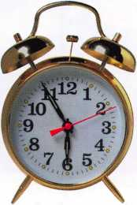

For

up-to-the-minute class information, visit our website at [www.aloa.org](http://www.aloa.org)

**WHEN SERVICING**

**IN ERCHANGEABLE CORE PRODUC S,  
HAS I EVER SEEMED LIKE  
SOME HING WAS MISSING?**

**-CORE**

**TM**

**T-CORE™: “Real” thumbturns for Small Format Interchangeable  
Core (SFIC) cylinders, including Best®, Arrow™ and Falcon™.**

ALOA members please respond to recorded message.

Call toll free 1 (866) 839-6286  
e-mail [tcore@ev1.net](mailto:tcore@ev1.net)

**Patent pending**

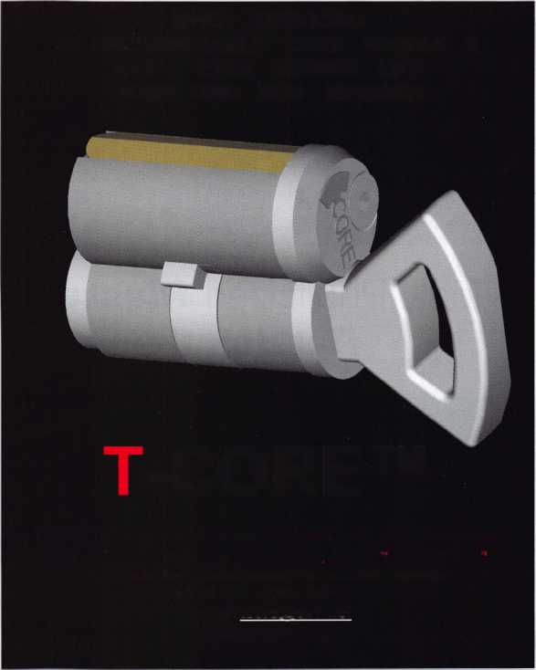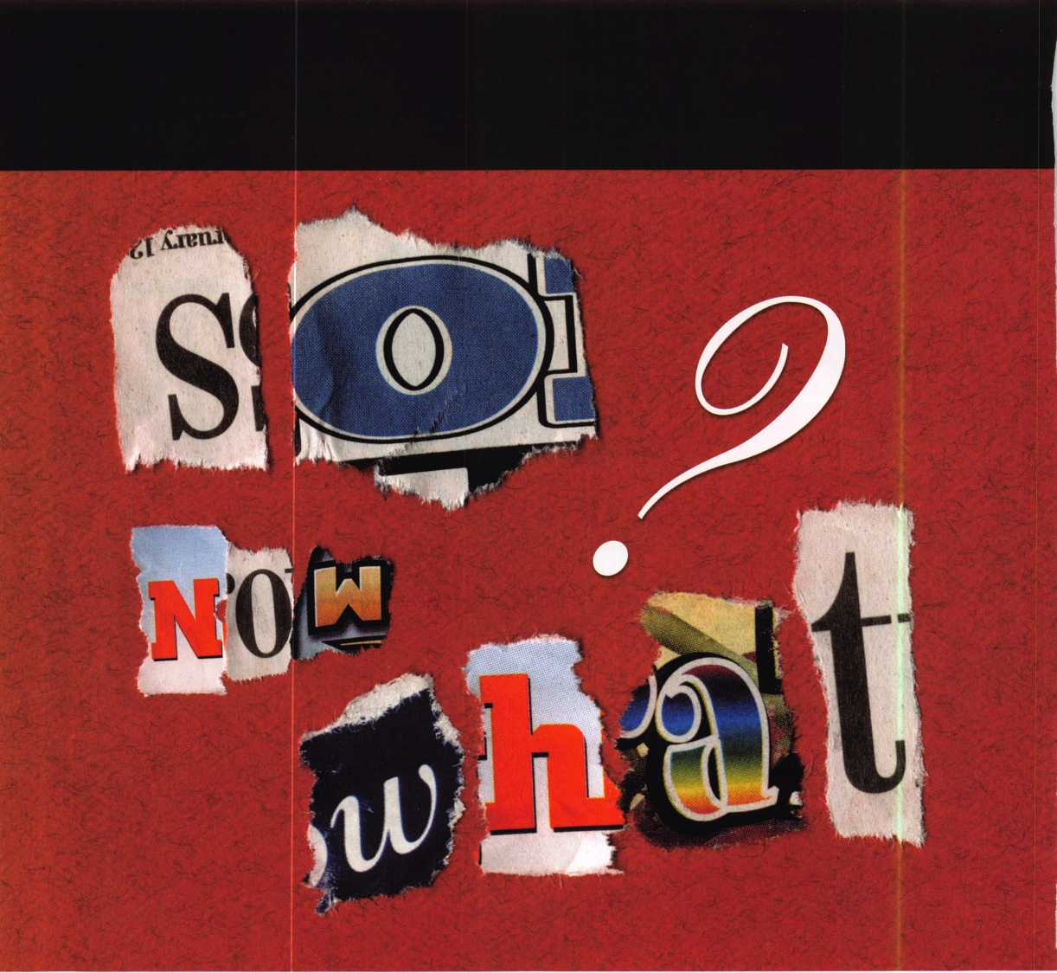

Widely Publicized Master-Key Hacking Method  
Rattles the Security Industry



Keynotes • March 2003

What Happened What ALOA Has Using it to your

Already Done advantage

When the New York Times recently ran a story last month reporting the master key forgery findings of an AT&T researcher (and that story was picked up by several other major media, including USA Today), reactions from within the locksmith industry ranged from one end of the emotional spectrum to the other. But the common denominator to all knowledgeable parties involved was a collective, “Who cares?”

“We are surprised at the medium of recent announce­ments of a technique for attacking master keyed cylin­ders,” read the official rebuttal to the New York Times article from the LIST council. “We would have expect­ed such revelations from an underground press for hackers or even in an anarchist cookbook, but not the New York Times.

“While the method has been well known by locksmiths for many decades (probably since the first scientific master key system was sold in 1889), only a few have bothered to document it. Most likely because it would only be valuable to those who would use it to the detri­ment of our society.”

The old adage of “no news is good news” is true many times - especially in an industry such as ours, where dangerous information exists, and spreading it can cause tremendous amounts of harm. It’s true that security professionals have known about master key forgery methods for as long as master key systems have been in place, but is it a good idea to let the general public know as well? The debate was sparked as soon as the master key forgery cat was let out of the bag by the New York Times.

“Those of us who are experienced in the field of master keying found the article laughable because it’s so obvi­ous and many of us have used the technique over the years for one purpose or another,” said renowned mas­ter keying expert, IR-Schlage director and former ALOA Board member, A.J. Hoffman, CML. “What is important to note however, is that this is BIG news to the general public that has no real understanding of master keying. It’s also big news to security directors and law enforcement officials who may know what mas­ter keying is, but don’t really understand its mechanical ramifications.”

True enough, which is exactly why some in the industry felt the news should never have been broken in the first place, the logic being that spreading sensitive security information is irresponsible, as it introduces the vari­able of human (dis)honesty to throngs of people in what was otherwise a sheltered scenario.

“Even though this is just one of many techniques of the locksmith trade,” read the LIST report, “we consider the widespread publication of this information to pose a significant risk to the public safety because of its potential to educate the dishonest among us. Locksmiths and manufacturers have long pointed out the potential loss of security from master keying.

Thus they have offered restricted keys and recommen­dations to limit the use of master keying for over 100 years. For example, exterior doors of buildings and cer­tain sensitive areas should not be master keyed.

“We feel it is a locksmith’s duty to point out to all his customers the potential for compromise this informa-

The common denominator to all knowledgeable parties involved was a collective, w'Who cares?”

Report by Jim DeSimone, Keynotes Editor



Keynotes • March 2003

Here are some ways to slow down and combat hacking into mas­ter key systems.

1. Specify patented key control systems - this prevents the use of commonly available key blanks.
2. Avoid master keying as much as possible. Instead, key-alike mul­tiple doors that require access by the same person(s) such as restrooms, copy room, lunch room, etc.
3. Never master key exterior doors or doors that lead to sen­sitive areas such as payroll, cash counting rooms etc.

4.Store individual keys in secure key boxes with audit controlled access.

1. Advise homeowners to have their locks rekeyed (removing the remaining master pins in the process) as soon as they take posses­sion of a new house.
2. Advise apartment owners to remove the master key system from apartments and keep an individual key for each apartment (for emergencies) in a key safe with con­trolled access.

tion constitutes. The layman does not have a concept of the number of locks master keyed in our world. As lock­smiths, we realize that this attack can be used everywhere from some residential areas to corporate America.

It is no longer a possibility so much as a probability”

Wait a minute — did the LIST report actually say “residential areas” as well?

Of course. Locksmiths have known about the possibility of forging residen­tial master keys for many years.

“I believe Mark Blaze’s original paper mentioned that the average homeowner isn’t at risk because those locks aren’t usually master keyed,” explained Hoffman. “On the contrary, there is a process called ‘construction master key­ing’ that affects virtually all tract homes built in the last 55 years. Even if the builder’s master key is voided by one of the customary methods, master pins still remain in the locks on every house and a person could reverse-engineer the mas­ter key to all or most homes that that builder built. Note that I didn’t say ‘in that tract’ because builders build many tracts and usually use the same builder’s master key everywhere.”

“Locksmiths see this often when called upon to rekey a residence for the first time — maybe after the house has been standing for 20 years. There are still plenty of master pins in the cylinder and, presumably, everyone has forgotten that a builder’s master key ever existed, but a derivative of that master key is still available for decoding.

“In the rekey process, locksmiths dis­card the master pins and key the lock to a new set of random keys, but all the locks on your block that have never been rekeyed or replaced can still be opened by a derivative of that builder’s master key”

There can be no doubt that the fact that this knowledge has created uncertainty and even danger within the profession. But is there something positive that we can do about it? ALOA believes there is.

“When I first read the NY Times article that reported on the research from ‘Hacking Into Master Key Systems,’

I had mixed reactions,” said ALOA Director of Education, David Lowell, CML, CMST. ‘As a locksmith who has been very aware of this methodology for years, I thought, ‘So what?’ - next, the NY Times will release breaking news that Lincoln has been shot!”

“I next thought about the average read­er finding out about this for the first time and realized that although there has always been the clouded intimation about skeleton keys or master keys that will open any lock, this was now in print in the NY Times, which many regard as gospel, giving the mystery behind master keys a degree of credibility.

“My business sense then kicked in, and I realized what an excellent marketing opportunity this is for professional locksmiths to sell patented key control and high security locking systems, if not for entire buildings, at least on sensitive areas.

“Locksmiths should reprint the NY Times article and make sure that all of their customers have a copy For years, in our keying conference meetings with customers who want master key systems, we have cautioned that master keying is the planned destruction of security and that less is better - now we have the NY Times to back up this claim, what a windfall!

“It doesn’t stop with commercial build­ings either; there have long been con­struction master key systems used in home building.

“The knowledge of master key system pitfalls is now available to the average consumer and it’s time for professional locksmiths to live up to the high stan­dards we promote, and not try to downplay the significance of this, but instead use the knowledge as a tool to truly provide the professional advice that is expected.

2

Keynotes • March 2003

Reflections on AT&T and the New York Times

Editorial by Jerome Andrews, CML

One of the ironies of being human is that as we uncover  
the complexities of things, we still insist on simple,  
absolute answers. Security has always been and will always  
be a matter of relative adequacy The only way I know to  
reach absolute security is to die, and even then, we are in  
the realm of faith.

Could a locksmith observe my car key, read it and make  
one? Sure. Am I worried about it? No. Do I need biomet-  
ric readers on my house? It might be convenient. For me,  
it would be a superfluous convenience. Are there end users  
or for whom such things are legitimate concerns?  
Absolutely.

Locksmiths have known for years that security is not a  
one-size-fits-all matter. Mechanical locks are one  
element to be complimented by other

devices and practices in a programmatic way.

Locksmiths know that a mechanical key sys-  
tem is a house of cards. At the start of every  
master keying class I teach for ALOA is an  
overhead that reads “Master keying is  
not a very good idea. Locks are puzzles,

and the best puzzle has a unique solu-  
tion that is difficult to find.” Master  
keying is a compromise to convenience.

The author of the internet piece, Matt  
Blaze, is a bright soul, but his discovery of

how easy it is to break a system is redolent of the  
naivete of teenagers who feel they are the first to dis  
cover sexuality. In fairness, security is topical and his  
concerns are legitimate.

Patent-protected blanks, keys that require special equipment, contracts, and restricted distribution are positive steps we have taken to increase security. They really help. Are they absolute? No. Can we stop a lock­smith or an enterprising apprentice from making a work­ing duplicate of a mechanical key? No. We can make it harder, and we can make it illegal. Does that help? Yes. Frankly, I’m more concerned about handguns and the fate of the working poor than people making keys on the sly.

We have serious issues with industrial espionage, terror­ism, electronic fraud and countless other problems. Lloyd Seliber has a principle that I find ethical and useful, viz., end users are entitled to understand the technology that is protecting them. Shaw said all specialties are a “conspiracy

against the laity.” It is not arrogant to ask a doctor to  
explain a diagnosis. It is intelligent.

Every end user needs to get good advice from trained  
people. They must assess their risks and the cost effective-  
ness of various precautions. Notice I said precautions,  
not solutions. There is no solution to the human problem.  
There are only precautions of relative adequacy. We can-  
not save the village by destroying it.

A university doing research on sarcophages and an auto  
parts store both have legitimate, but very different securi-  
ty concerns. If the university is protecting the pathogens  
with grade 2 mechanical locks and patented key control  
cylinders only, they have a competence problem and we  
are all at terrible risk.

I tend to see things through a moral optic. As our chil-  
dren grow up, they learn that the world is imperfect  
and that people do things they shouldn’t.

Early on in the development of Medeco origi-  
nal product programs the decision was made  
to have specific keyways for certain regions  
of the country. One consideration was a  
legitimate fear that some locksmiths in  
those markets would not “play the game by  
the rules.”

Perhaps the recent Times article will spur  
further interest in more effective security  
products and methods. That’s good.  
However, what one person can design,  
another can reverse engineer. This is  
ultimately a problem of human behavior.

These articles may provoke a certain amount of  
harrumphing in high places and talking heads may  
interview experts. But we are so short of attention span  
that we will quickly pass on to other things.

We, as a nation, regularly mistake the urgent for the  
important, and are profoundly confused about the differ-  
ence between peace and security. My old friend, Gene  
Simon, counsels me, “Jerome, war is always.” I fear he is  
right. We cannot escape our moral dilemmas and social  
responsibilities. All we can do is act as honestly and  
responsibly as we can.

Keynotes • March 2003

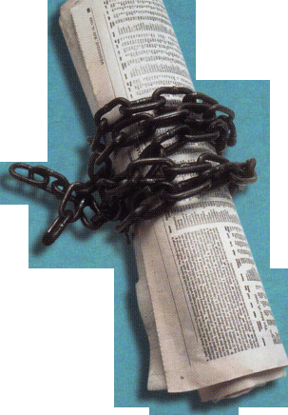

by Greg Perry, CML, CPS

of Electronic Access Control



It’s a shame that we’re this far into the electronic access con­trol revolution in our industry, and there is still a vast army of locksmiths who either haven’t taken the electronic plunge, or who are, at the very least, timid about their command of access control applications, products, and servicing/installa­tion techniques.

So, what is it, what parts do we need, and how do we install it? Some simple questions with some simple (and some not so simple) answers. Let’s start with the “what is it” question. The basic system consists of a power source, some wire, an on/off switch, and an electrified lock or strike. The most elaborate systems use the same basic concept. They add a few parts (e.g., a card reader) attached to a control or brain, but the concept is the same. This article will explain much of the basics, but on-the-job training will be required to master the skills needed to be a good technician.

Note: If you want more information, I will be teaching a class on this topic at the ALOA 2003 convention in Las Vegas.

SAFETY

Working with electricity requires a few extra safety precau­tions. In general, access control carries a low voltage (12 or 24 volts), but the input power is higher (usually 120 volts, alter­nating current). Any time you work around electrical devices with voltages over 50 volts, you should lock-out/tag-out the energy source. This means shutting off the power and secur­ing it with a padlock tagged with your name. Most of the time, low voltages will not harm you, but shorting a tool across battery terminals can cause the battery to explode or heat up possibly starting a fire. (Don’t ask how I know this, but I did lose a shirt one day when a battery fell over in my truck.) Higher voltages exist in power supplies and other equipment; either turn the power off or use great care not to touch live terminals. One trick my father taught me is to only use one hand when working on live equipment. You still may receive a shock but it won’t go directly through your heart possibly stopping or disrupting its rhythm.

CODES

Before installing any equipment, before selecting any equip­ment, before quoting a job, we must have a basic understand­ing of codes and know who is the AHJ or ‘Authority Having Jurisdiction.” Unfortunately for us, there are multiple codes and the AHJ will change from job to job. Some jurisdictions will require all wire in conduit; others will not allow a magnet lock of any type. Since codes are national, regional and local, this article cannot cover them all adequately NFPA 70 or the NEC (National Electric Code) is probably the primary code to follow. In general, it refers to very little about low voltage installations. The important thing the NEC addresses is to install as per the manufacturers instructions. Regional codes such as the Uniform Building Code also have little require­ments regarding low voltage. The codes that will most affect your individual installation are usually local codes. This is where the AHJ will be the most important person involved

with the installation. Cultivate a good working relationship with the AHJ. The best rule to follow when doing any job is “Olin’s Law,” which says, “Treat every job as if there WILL be a fatal fire in the building TOMORROW and You WILL BE IN COURT the next day to explain your actions or inactions.”

ELECTRICITY

Electricity is generated in two forms; Direct Current or DC and Alternating Current or AC. DC is a constant voltage typically generated from a battery or from converted AC.

AC constantly changes from a positive voltage, to no voltage, to a negative voltage and back to no voltage before going pos­itive again. See figure one for a graphic representation.

AC Changes POLARITY (or direction) back and forth

+ 12 volts

0

-12 volts

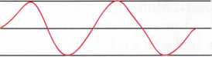

DC is constant

+ 12 volts

0

Since electricity cannot be seen, it is often compared to water. This is not a perfect comparison, since water will flow without demand whereas electricity is drawn out or is only used as needed. Electricity also has different terms applied to it. Voltage is the pressure or force pushing electrons through the wire; this can be compared to water pressure or PSI. Current or amperage is the amount of electricity being used; this can be compared to the number of gallons. Power or wattage is a combination of the two; the voltage times the amperage. This is a good measure of the amount of work that is being done. Resistance is the opposition to the flow of electricity, friction to water flow; it is measured in Ohms. In the same way as a hose will only allow a limited amount of water to go through it at a fixed PSI, a wire will only allow a certain amount of electricity to flow through it at a fixed voltage. If we need to increase the amount of water we need to increase either the pressure or the size of the hose. If we exceed the rating of the hose, it may burst. The same is true of wire; if we need to increase the amount of power, we must increase the voltage or the size of the wire to handle more current. If we exceed the rating of the wire, it may “burst” or melt. In most cases, if more power is needed, you cannot increase the voltage, so you must increase current, necessitat­ing a larger wire.

As you might guess all four — power represented by the let­ter P, voltage represented by the letter E, amperage repre­sented by I, and resistance represented by R — are related. Watt’s Law says W = E x I; Ohm’s law says E = I x R. With these formulas, we can perform most of the calculations we need as access control technicians. An example of where these calculations might be needed is to calculate the size

Keynotes • March 2003

of wire needed for a given length. It’s also useful during troubleshooting to verify the proper gauge of wire. Often the manufacturer will provide you with the answer in the form of a table of wire sizes for given lengths. IVe been on several jobs in which a previous company undersized the wire. This is important because of voltage loss to the resist­ance of the wire or voltage drop. The recommended volt­age drop should be no more than 2 percent of the voltage. At one installation I saw, the original company installed 150 feet of 24-gauge wire. Because voltage drop is calculated for the total amount of wire and two wires are used (one posi­tive, one negative). This doubles the overall length of the wire for a total of 300 feet. Voltage drop can be calculated using Ohm’s law. This installation used a Von Duprin 12- volt electric strike using 300 milliamps or .3 amps; resist­ance of 24-gauge wire is 26 ohms per 1000/ft. or approxi­mately 8 ohms per 300/ft. Multiply **.3x8** = 2.4 volts of loss. Now divide 2.4 by 12 = .2 or 20 percent. This is unaccept­able! It will cause the strike to work harder and possibly blow fuses. If this is too much math, stick to the recom­mendations from the manufacturers. A good rule of thumb is to use 18-gauge wire minimum. If you have longer dis­tances or a large current draw, do the calculations or ask the manufacturer.

Electricity can be stored, blocked or modified with various components. Batteries provide long-term energy storage. Rechargeable batteries will usually charge and discharge at various rates. They can store electricity for use in the future. Capacitors are short-term storage devices. They can discharge all of the energy at once or slowly, but they will not store electricity for a long time. Capacitors are very useful for providing a surge of energy to kick or start a sole­noids or motors. Diodes allow the flow of electricity in only one direction. Metal Oxide Varistors or MOVs are used to prevent a surge of voltage from passing. Diodes and MOVs are used to protect equipment.

Resistors use or modify electricity. They can be used to reduce the voltage. Most alarm and access control panels use resistors attached in line with a contact to tell if the door is open or closed. Each manufacturer will ask for a specific resistor value. An example might be a 5600-ohm resistor. Resistors have three or four bands or stripes.

They are color coded for value. The first two bands are lit­eral numbers; the third band is the multiplier (or how many zeros). The fourth band is tolerance. The meaning of the colors is shown in table 1. Using the table, a resistor with three red stripes and one gold stripe would mean the resis­tor is 2200 ohm with a 5 percent tolerance. Green, Blue, Brown, Silver would mean 560 ohm 10 percent tolerance.

Table 1:

Black = 0 Red = 2 Yellow = 4 Blue = 6 Gray = 8

Brown = 1 Orange = 3 Green = 5 Violet = 7 White = 9

There are three types of circuits: parallel, series, and com­bination circuits.

Two Switches in PARALLEL

Battery

Two Switches in Series

Combination circuits

Two switches in parallel and one switch in series

|  |  |  |  |
| --- | --- | --- | --- |
|  |  |  |  |
| -r- |  | / | / |
|  | / |  |  |

OPEN

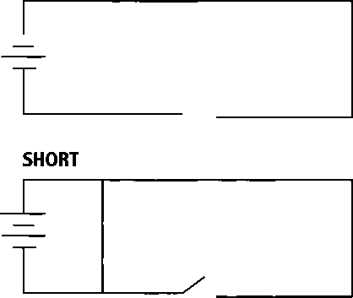

EQUIPMENT

The core or backbone of most electronic access control systems is the wire. Wire is available in various sizes or gauges — the larger the size, the smaller the gauge. Most access control systems will use 16 to 22-gauge. It comes in two styles — solid and stranded — meaning several small wires twisted together to create one larger wire. It also comes wrapped in various jackets. This is where the codes may require a specific type of jacket. An example is where



Keynotes • March 2003

the area above a drop ceiling is being used as a return air space for the heating/air conditioning system. Any wire in this area must either be in conduit or have a plenum-rated jacket. Some wire is shielded to reduce outside interference from transformers or other sources of electrical noise.

If you are not familiar with the type of wire needed, ask the manufacturer or your supplier.

Power supplies are available in various sizes and types from a simple plug-in transformer to elaborate power supplies needed for high current draw of a Von Duprin electric latch retraction exit device. In general, the manufacturer of your equipment will specify the voltage and current needed to operate its equipment. Add all the power requirements for the equipment attached to the system to get the minimum power supply size needed. Don’t forget to add battery charging needs if you have battery backup. Also, as you specify batteries, remember batteries are rated in voltage and amp-hour capacity.

A common battery is 12 volt 7 amp-hour. This means the battery can provide one amp of power for seven hours, two amps for 3 1/2 hours or 1/2 amp for 14 hours. Once you know how many amps the system is going to draw, you can size the battery (or batteries) to provide the backup capaci­ty you need. Equal size batteries in series increase the volt­age, i.e. two 12-volt 7 amp-hour batteries in series equals one 24-volt 7 amp-hour battery. Batteries in parallel increase the power available; i.e. two 12-volt 7 amp-hour batteries in parallel equal one 12 volt 14 amp-hour battery.

All systems need protection devices against over current draw and against return surges from the electric locks.

Fuses and circuit breakers are installed in the power supply, sometimes only on the output and other times on both the input and output side of the power supply. Diodes and MO Vs are added at the electric lock to prevent a surge from returning to the control.

The electric lock needs to be controlled or turned on and off by some type of a switch or relay. Relays are electrically- controlled switches. Switches, as you might imagine, are available in many different styles, ratings, types and shapes.

**SPST Single Pole Single Throw DPST Double Pole Single Throw**

**SPDT Single Pole Double Throw DPDT Double Pole Double Throw**

Switches can be momentary or maintained. Momentary is like the start position of your truck ignition. Maintained is like the run position. The terminals on multiple position switches and relays will be labeled. The most common method of labeling is “C” or common, “NO” or normally open, and “NC” or normally closed. Normal is described as how you get it “out of the box.” Release switches are added into exit devices; they’re found in motion sensors and touch sense bars. They can be provided at the reception desk for remote release. All provide the same function, a means to signal the electric lock to unlock.

Electric locking hardware is also very diverse. The most common is electric strikes provide a keeper to hold the latch, and when released, the lock is no longer kept captive in the keeper, allowing the door to open. The next most common type is an electrified lock and panic lock. In most cases, a solenoid provides a block or lock preventing the knob or lever from turning. Some panics have a solenoid or motor that retracts the latch bolt. Another very common electric lock is the electro-magnet. They are available in various sizes, holding forces and applications.

TOOLS

The last topic to cover in this article is tools. Many of the tools you currently carry are used for access control work. Screwdrivers, hammers, drills and other common tools are used. Some specialty tools are needed; most can be pur­chased, as the work requires them, and others are needed from the start. Start your collection with some hand tools; wire cutters strippers, and needle-nose pliers. Add some long drill bits (3/8” seems to be a good size hole). You should have 12”, 24” and 48” or 60” lengths. Some bits can also be used for pulling wire, but you will also need a fish tape, some pull sticks and bent wires. Also needed is a good quality Volt-Ohm meter. If you can afford it, purchase a meter that can also measure DC amps, up to 10 amps. Meters are available in both digital models and analog mod­els. Digital meters have a LCD display. Analog meters have a needle, like most speedometers. Tour first meter should be a digital. Analog meters will work, but are often not as accurate. Other tools to add later include a tone generator and receiver used to trace wires, and a battery tester. You may also want to add some more tools like templates or programmers for very specific applications.

PANELS

I don’t want to cover panels, since this is a topic subject to your own preference. Many fine panels are available; each have their own strengths and weaknesses. It’s up to you to decide which will be best for your customers. I will make the recommendation to find a brand or two that fit best for customers and stick with that brand. Learning the quirks and programming for many different panels can be confusing.

This article covered the very basics of electronics and tools related to access control. It is a start of your educa­tion. ALOA and regional associations offer more in-depth classes, some hands-on. The class I will be teaching at ALOA 2003 in Las Vagas will be a combination of hands- on and theory. You can also take classes at your local com­munity college in electronics. Any education you can get in electronics will help you better understand electronic access control. The access control business can be very profitable. It can also be very frustrating when things go wrong, but develop your skills and like any part of this business, the problems become smaller, easier to deal with, and fewer in number.

Keynotes • March 2003

Part 3

By Sal Dulcamara, CML

In this final part of this article series,  
we will deal with CyberLock inter-  
changeable cores, CyberKeys, and  
programming and auditing of the  
system. But to quickly review, the  
assortment of lock cylinders shown in

photograph i is a small sampling of where the  
CyberLock system can go, with a minimum of labor and  
with virtually no scarring or damage of entry points and

doors (so things can be returned to their previous condition  
with little effort). Videx is currently making 34 types of  
electro-mechanical CyberLock cylinders that can go into  
most common and uncommon locking devices. With mor-  
tise and rim cylinders, Videx can go into most mortise lock-  
sets and exit devices. Cylindrical locksets can be taken care  
of with a variety of knob and lever type cylinders.

There is one very broad category of lock that is typically not very easily adaptable to electronic access control. That

category is interchangeable cores. Think how much space is  
taken by the electronic components that modify a standard  
access control device that (for the most part) adds onto an  
otherwise mechanical lockset. We have seen how compact

and small the CyberLock components are and how

easily they fit within the physical limits of very  
% small lock cylinders. Included with those  
components are the electro-mechanical ele-

ments, plus data storage and microprocessor.  
Those components are yet small enough to  
fit within a CyberLock small format inter-

changeable core (SFIC).

CyberLock Interchangeable Cores

While we have acknowledged that CyberLock goes pretty much where standard electronic access control can go and also in a large variety of specialty locked containers, there is no more instantaneous installation than placing an I-Core

a

8

Keynotes • March 2003

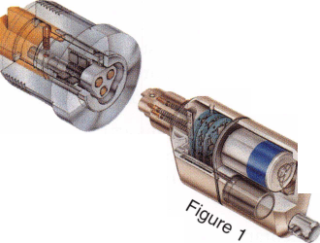

into a compatible IC housing. Photograph 2 shows a CyberLock small format interchangeable core with a stan­dard CyberKey. When operated with the standard key, in photograph 3, only the plug rotates. The back view from photograph 4 shows the drive pin holes are out of position, which indicates the plug has been rotated. But if you look at the control/locking lug, you'll see it remains extended and locked. The control version of a CyberKey has an extended tip, as shown in photograph 5. When this key is used, the lug retracts as shown in photograph 6. While the electronics and other internals of a standard CyberKey are otherwise identical to the control CyberKey, the different tips will limit how they can be used with IC CyberLock cylinders. Limited issuance of control keys and specific key programming restrict unauthorized removal of I-Cores.

Beside the small format physical profile, Videx also makes a CyberLock I-Core that is compatible with the Schlage large format profile. The overall physical layout varies some, but the I-Core in photograph 7 clearly has the same basic contours and the outward shape of a mechanical Schlage large format I-Core. When a CyberKey has been programmed to operate an I-Core (and it is within its authorized day and time for access), it will actuate the lock as in photograph 8. Notice that although the CyberKey is turned, the I-Core retaining pin remains extended. The control CyberKey in photograph 9 is of the same design used earlier with the small format I-Core, with an extended tip on the CyberKey. When used with the Schlage style large format I-Core, the control CyberKey retracts the retaining pin as in photograph 10.

The CyberLock's strictly mechanical counterparts are such that the small format I-Cores would require one control key and Schlage large format I-Cores would require a dif­ferent control key. Because the internal electronics of both format CyberLock I-Cores are essentially the same, it is possible to program the same CyberKey to operate both format I-Cores or a control CyberKey to remove and install I-Cores of both formats. I wouldn't be too surprised to see other brand IC formats become available as CyberLock cylinders from Videx.

The Key to CyberLock

The illustration in figure 1 shows a cutaway view of a CyberLock cylinder and an all metal case CyberKey. There are electronic components in both the lock cylinder and the key, but the CyberKey is not like any other electronic key currently available. In certain ways, it is part of the sys­tem's greatest strengths and weaknesses at the same time.

If you haven't noticed it already, the CyberKey is somewhat large. It is not much larger than a car remote, but for cer­tain potential customers it may become a sticking point and potentially a deal breaker. Part of the reason for the

somewhat large size is  
the 3-volt lithium bat-  
tery inside. As I have  
already indicated, the  
power to operate the  
locks comes from the  
keys rather than the  
locks. That is a rather  
significant reason why  
the CyberLock cylin-  
ders can be made so  
small and capable of  
being installed in so  
many different locking  
devices. Beside the  
control CyberKey vari-  
ation, photograph 11  
shows the various ver-  
sions of the electronic  
CyberKeys. On the far  
left is the CyberLock

Programming Key, which is also just referred to as the  
"Programmer." It is not used to operate the CyberLocks,  
but merely to transfer data back and forth between the  
computer and the locks. On the right is the DuPont Super  
Tuff nylon case CyberKey, and in the middle is the all-metal  
case CyberKey. The main differences between the two ver-  
sions of CyberKey are the looks and that the metal case  
version will be more weather resistant.

There are different "areas of intelligence" found in both CyberLock cylinders and CyberKeys. The areas of intelli­gence for the lock are as follows:

1. Unique ID (for lock)
2. Password (Encrypted)
3. List of Lost Keys (by electronic ID)
4. Audit-Last 1100 events. Events include openings, item­ized by Key ID (which opened) and Day & Time of Opening. Under standard programming, Denials of Access are only recorded by the lock when a "Lost Key" attempts access, or a key from another system. Key ID and Day and Time of opening attempt is recorded. Special programming can cause all events to record.

Since the battery is contained in the key rather than the lock, the clock is found there rather than the lock. When the time and day are recorded in either device, the key gen­erates the time. The areas of intelligence for a CyberKey are as follows:

1. Unique ID (for Key)
2. Password (Encrypted)

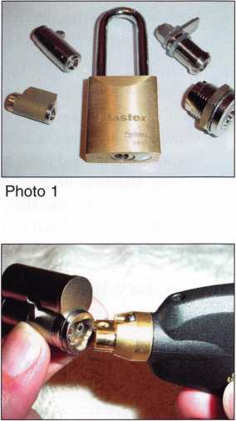

Photo 2

Keynotes • March 2003

1. Lock Schedule-this details which locks are accessible by this key, plus time and day of access.
2. Audit-Last 1150 events. Under standard programming, the most current 1150 events are retained. When that number is exceeded, the oldest events are dropped. Unlike the lock (under standard programming), all events are recorded-both openings and denials of access. Alternate programming can limit the key to 1150 events and it can then switch off further access until the key is audited and the computer captures those events.

Lock & Key Interaction and Operation

The fact that the battery is in the key rather than the lock kind of makes the key the senior partner. The lock sched­ule is contained within the key and the key ultimately tells the lock what day and time it is and whether or not it is supposed to have access at that time. The standard steps of lock and key interaction and operation are as follows.

1. Key touches lock
2. Power (in the key) energizes the electronics in the lock.
3. Lock & Key exchange (unique) IDs. Key checks to see if lock is part of same system/family. If okay, the lock schedule is checked.
4. Key checks its lock schedule to see if it will work with that particular lock, and if it is the correct day and time for access. If OK, next step.
5. Encrypted passwords are exchanged. If passwords are accepted, the solenoid is energized and the CyberKey will be able to operate the CyberLock.

Under standard programming, the key will timestamp the event and it will be recorded by both the lock and key. If a denial of access takes place somewhere between steps 1 and 5, the key will always record the event but the lock will

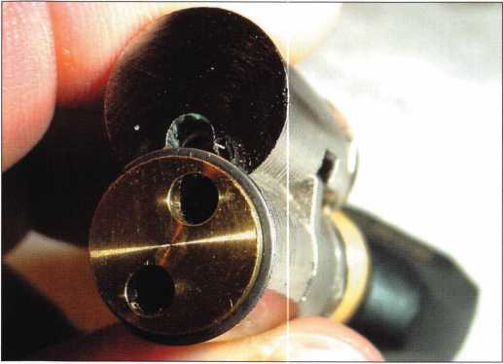

Photo 4

record it in certain  
circumstances (some  
indicated earlier in  
the article). If the key  
is on the lock's list of  
lost keys, access will  
be denied upon  
exchange of unique  
IDs. Special pro-  
gramming can change  
some of the specifics  
identified.

Both the CyberLocks and CyberKeys can be audited. The CyberKey Station, shown in photograph 12 is what allows the computer to communicate and exchange data between locks and keys. The Programmer (or Programming Key) can receive the entire audit data from one CyberLock and can also contain lock programming information for multiple CyberLocks. Standard CyberKeys may be used to download individual locks.

Applications and Limitations

Non-volatile memory is used in both the locks and keys. The locks do not need power to retain memory Lock oper­ation, programming and auditing will require power, but the CyberKey will generate that. The clock in the CyberKey will stop if the battery goes completely dead, but all other data will be retained. The keys are not cheap, but it is the batteries that have to be changed rather than the keys. The keys, therefore, may have an extraordinarily long life. They can be audited and reprogrammed numerous times. The battery life will vary depending on usage. In general, the batteries will need to be replaced at least every 6 months. High usage and weather or environmental condi­tions will reduce battery life, and more frequent replace­ment may be needed. If the low battery warning is heeded, it is possible to replace the batteries within one minute and not shut down the clock. If you wait more than a minute to replace the battery, the CyberKey will not allow

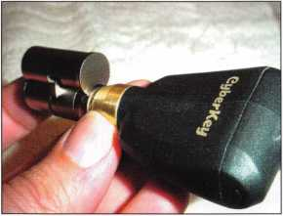

Photo 3

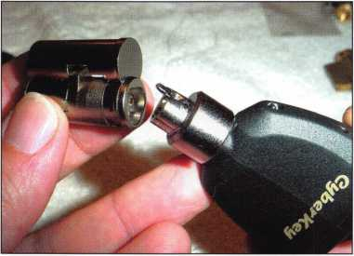

Photo 5

Keynotes • March 2003

access until you bring it back to the CyberKey Station and reset it. The two standard style CyberKeys use a CR2 3 volt lithium battery. If the battery life of a standard CyberKey is inadequate, a special use key is available with approximately twice the battery life of a standard key. It uses an EL123 3- volt lithium battery.

It is possible to change the battery settings (in the key) to extend the battery life of either the standard or special use keys. When the CyberKey touches the CyberLock and access is granted, the default setting is to hold the solenoid in the unlocked position for 3 seconds. It is not recom­mended to reduce that time until key holders get used to the CyberLock system and the CyberKeys. After a while, though, you could reduce the 3-second rate to 1 second and extend battery life. There are also four voltage settings: low, medium, high and maximum. Medium voltage is the default setting. In cold or other intemperate conditions, it may be wise to increase voltage settings if the key doesn't seem to have enough power.

The Videx CyberLock system is a very interesting and unique access control system. I have mentioned a variety of circumstances that make it stand out compared to other competitive products, but here are a few more to consider. If temporary restricted access is required, I can't think of anything that is less obvious and so easy to convert one way and back again than CyberLock. There are also certain

entry door applications where Videx has probably your best option for electronic access control. Expensive, decorative or generally untouchable doors can be converted to elec­tronic access control with just a switch of the lock cylinder and no drilling or permanent scarring.

Something new called the CyberKey Authorizer allows remote access authority where CyberKeys can be pro­grammed on a daily basis through a programming port and lost keys won't matter because they aren't reauthorized. I'm sure you can think of a few other applications well suited to the Videx product line. Lor more information, contact: Videx, 1105 N.E. Circle Blvd., Corvallis, OR 97330. Phone Number: 541/758-0521 LAX: 541/752-5285. Online at: [www.videx.com](http://www.videx.com)

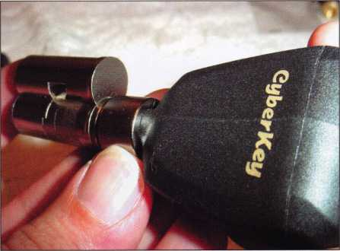

Photo 6

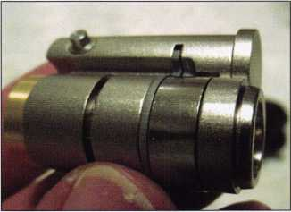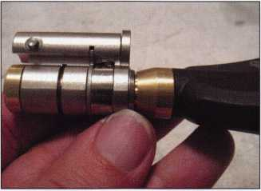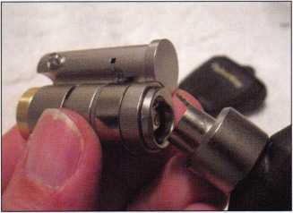

Photo 7

Photo 10

Photo 8

Photo 9

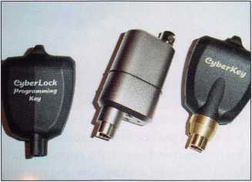

Photo 11

Photo 12

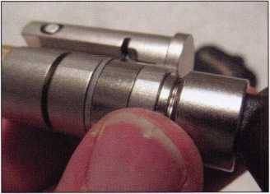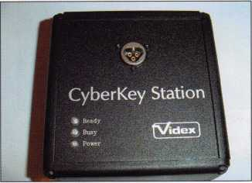

Keynotes • March 2003

2000 Ford F-150 Harley Davidson, Part 2

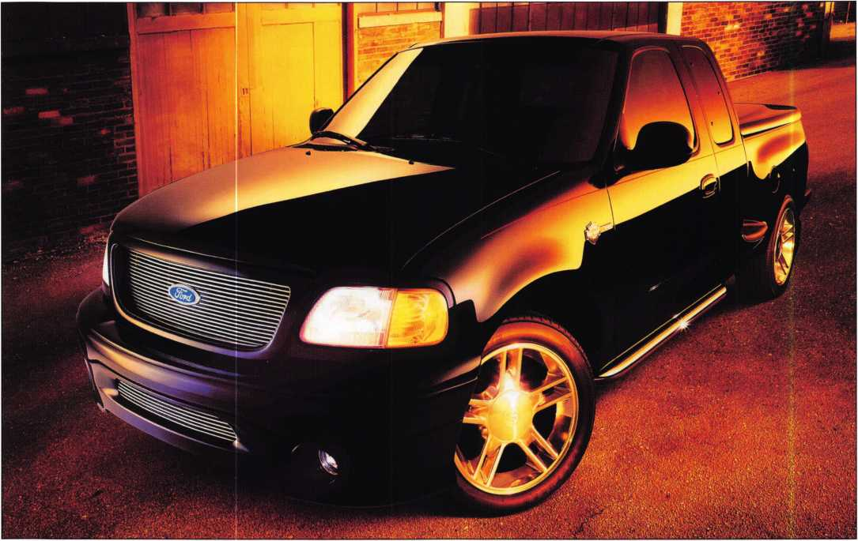

Last month, we looked at the servicing and installation of the mechanical aspects of this gorgeous  
custom truck. This time, let's take a step-by-step look at the programming sequences for the

truck's transponders.

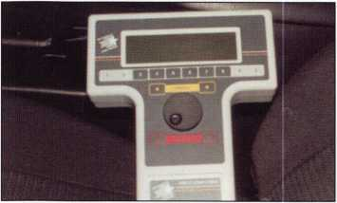

1. The NGS tool on the driver's seat. So far you only need the one plug for all Ford, Lincoln and Mercury models.

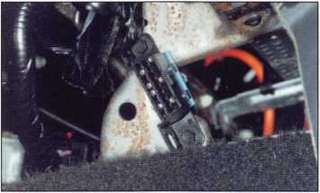

1. This is where the converter is mounted.

It is located just above the carpet line over the transmission hump in the center and just behind the center console. The plug can only go on one way, so watch what you are doing to prevent any damage to your test equipment, or the vehicle.

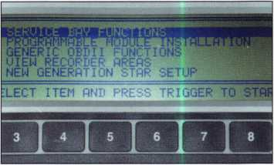

1. The second thing you see after you plug in. This will occur automatically after the ini­tialization. It will start at service bay func­tions. Press the button to the left or right of the word "trigger" to continue.

Keynotes • March 2003

1. The second thing you see after you plug in. This will occur automatically after the initial­ization. It will start at service bay functions. Press the button to the left or right of the word "trigger" to continue.
2. The next function. Scroll down to HEC-Hybrid Electronic Cluster. Press "trigger." The selec­tions are different per make, model and year.
3. Next function. Scroll down to Security Access and press "trigger."

HEC PROTOCOL* ' W.

IfiBLE TO PERFC IT RESPONDING IECK IGNITION §IFY COBLE RE IECK COBLE COI-

7. Next function. Scroll down to Mustang and press "trigger."

8. Next function. Wait a moment.

9. I usually see this screen when I forget to turn the ignition cylinder to the "on" position. If this happens, press cancel and you will return to the previous screen. Turn the ignition on and continue, as before.

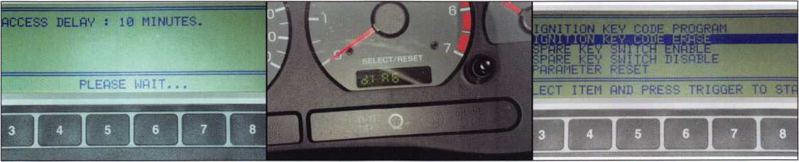

10. Next function. If you are successful, the screen shows "Access Delay: 10 minutes." If you have nothing to do for 10 minutes, you can play electronic Yahtzee, or in knowing your programming will be successful, you can write up the bill. You are not trapped or com­mitted to the vehicle; you can get out and do other things, like make a trunk key if it is a two-key vehicle. Or, call the florist and send your wife flowers like I did. (It was Valentine's Day.) You get the picture; you can do other useful things in 10 minutes.

11. This is what happens on the instrument cluster once you've successfully started the program­ming procedure. You will see "dlAG," which could be short for "diagnosis"?

1 2. Next function. Scroll down to Ignition Key Code Erase and press "trigger."

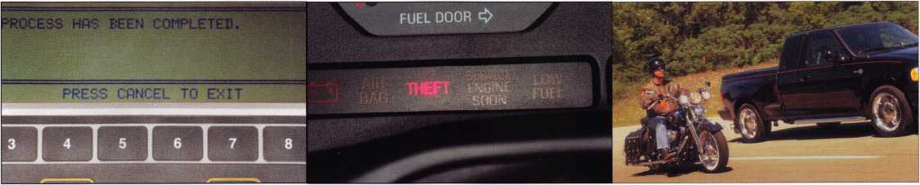

1 3. Next function. Consult your programming  
procedure to program one or two keys,  
depending on the year and model. One of  
the places you can obtain programming  
information is from the dealership. Not all  
dealerships are locksmith friendly.

14. The theft light on the instrument panel. This light is used for programming additional keys.



Keynotes • March 2003

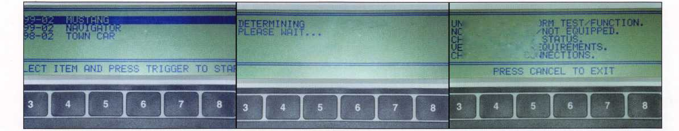

by Eric A. Costley, CRL

No, you won’t see this one driving up into your shop parking lot. Even so, it may take you for a bumpy ride! Many locksmiths have choice words for describing Ford products, and most of them can’t be repeated here. Well, here’s yet another Ford to describe with flowery adjectives, and Henry Ford had nothing to do with it! In my 20-plus years as a lock­smith, I’ve seen only two of the old Ford penny gumball machines. They were manufactured in the 1950s, and many are still in use today. Currently, they are the rage among collectors, and they even still manufacture little square chicklets of gum with the Ford logo on it. If one of these finds its way to the back room of your shop with a repair tag on it, take the rest of the day off and go drown your sorrows. This is not something that you can tackle in 30 minutes! Unfortunately, E-Bay and other web­sites are full of these machines, and they command a high price... but that, my friend, is your sole advan­tage when attempting to fit a key to one of these.

Figure 1 shows the culprit in all of its deceptive innocence. Figure 2 gives you that initial gasp that you draw when you suddenly realize that your shop help has severely underquoted

the job. I immediately called the customer back, and I won’t tell you how much I told her it would cost. But she didn’t flinch, nor did she balk at the fact that I told her that it would take me a month to do it. (OK, it was two and a half, but who’s counting?) In any case, she eventual­ly walked away a happy customer.

Now, take another look at Figure 2. How about that keyway configura­tion? Think that you’ve got a box of 50 of these blanks in the back room? I think NOT! I began this project by robbing a spindle from a used LaGard electronic safe lock: This was a nice substantial chunk of brass that would do nicely After doing some milling on the Framon and the HPC Laserpoint, I had my basic blank. The next step was to open and disassemble the lock.

Each of us at the shop took turns swearing at this beast. When I was a mere apprentice, my brother had taken one of these into the shop, and I was the one who had made the key for it! Still, after some 20 years, my memory was hazy at best, and neither I nor anyone else at the shop was able to manage to pick the cylinder. Finally, we got permission from the owner to grind down the

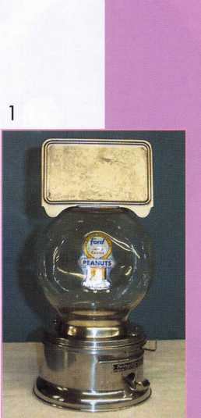

Each locksmith took turns swearing at this beast.

Keynotes • March 2003

2

rivets on the top rim that held the  
globe in place, and this gave us

enough room to rotate the  
entire cylinder 90

degrees for removal.  
After removing a roll  
pin and pulling the  
plug out of the hous-  
ing, we not only real-  
ized why it was so  
difficult to pick, but  
found that one wafer  
was missing and two

were damaged, making it  
virtually impos-

sible to pick. A  
sigh of relief  
resounded  
through the  
shop as we  
closed up that  
night, certain  
that we were  
now actually  
making progress.

Take a close  
look at the dis-  
assembled cylin-  
der in Figure 3.  
Notice that the  
wafers are some-  
what reminis-  
cent of the split  
wafers used in  
Toyota and  
Lexus locks,  
except that

there is only “half a wafer” at use in each position. At this point, it became obvious that the tip of my handmade blank needed a fierce bevel on the top edge to “raise” the wafers — horizontally, of course. All of the wafers in these locks are spring-loaded from the same side of the plug. In an attempt to pick one of these locks, hold your pick side­ways and attempt to manipulate the wafers, (at the top of the keyway,) from the left side of the keyway toward the right. The plug is rather sloppy in the cylinder housing, and you will probably have to manufac­ture your own tension wrench to tackle such a wide keyway, but I’m confident that if the lock is working properly, it could certainly be accomplished.

Putting the cuts on the blank was pretty interesting. I’ve prided myself on my impressioning skills for years, but on a lock that works somewhat like a sidewinder, you have to leave wonderful little rolling slopes on the key, not nice sharp cuts like I’m accustomed to making. In addition, if you look at Figure 4, you will see that the second cut from the bow was so deep that it nearly bisected the key entirely, and were it not for the beefy bottom section of the blank, I would’ve had two pieces instead of a working key.



Keynotes • March 2003

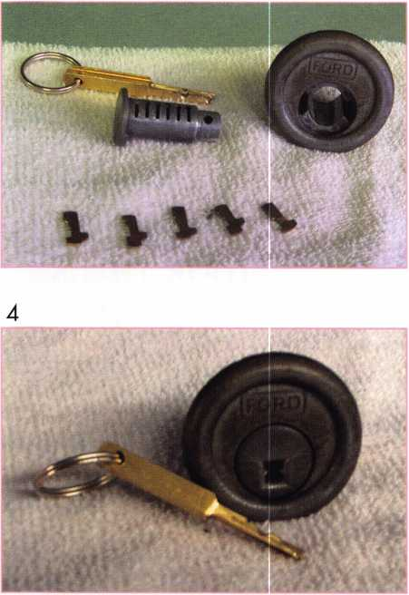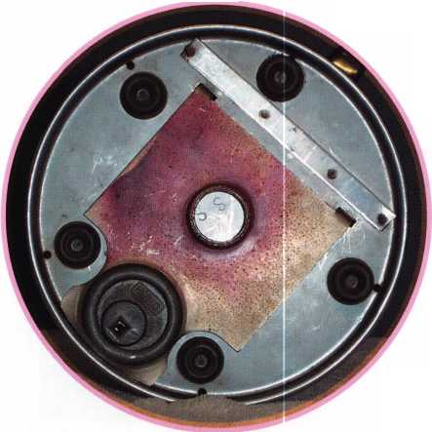

Among all of the other joys of this adventure was the usual humor that always circulates at the shop. Besides all of the other digs and snide com­ments, I would say that the highlight of this particular job was watching the son of one of the owners attempt to chew one of the pieces of antique gum that was lodged in the machine. Evidently, although the consistency was unusual, the flavor was still intact. (Ewwww!)

The really fun part of working on something like this, (aside from the obscenities and the need to drink compulsively while you are working on it), is the wonderful sense of accomplishment when the job is finally finished, and you collect the paltry amount of money that you miserably underquoted as the delighted customer walks out of the door.

Notice that the wafers are some­what reminiscent of the split wafers used in Toyota and Lexus locks



**Colorado Security Professionals Education Conference**

April 24, 25, 26, 2003

Brought to you by the following:

* Central & Southern Colorado Locksmith Association • Rocky Mountain Locksmith Association
* Colorado Burglar & Fire Alarm Association • ALOA Front Range Chapter

Thursday, April 24, 2003

4 Basic Locksmithing (Day 1 of 2) 4 Masterkeying 4 Jail and Prison Locks • Access Control (Day 1 of 2)

Evening:

Free Dinner Buffet  
and Trade Show

Drawing for a  
Free Convention Package  
at ALOA Las Vegas

and Prizes 6pm to 10pm!

Friday, April 25, 2003

4 Basic Locksmithing (Day 2 of 2) 4 Small Format 1C core (PRP)

4 Safe Lock Service & Troubleshooting (PRP)

• Access Control (Day 2 of 2)

Evening:

Fun Night Out!

Bus trip to

Colorado Central Station  
Casino Blackhawk  
One of Colorado's  
Oldest Mining Towns

Only $10.00!

Saturday, April 26, 2003

4 Large Format IC Core (PRP)

4 Servicing Aluminum Storefront Doors 4 Electronic Safe Lock Service • Life Safety Codes

Evening:

Free Labor Saver Class  
ALOA PRP Testing

Gordon Racine, CML 719-384-4707  
Barry Meyer, CRL 303-688-4104

LOCATION: Radisson Stapleton Plaza • 3333 Quebec Street • Denver CO 80207  
HOTEL RESERVATIONS: Local: 303-321-3500 • National: 800-333-3333

Please thank and support these generous show sponsors: IR Security & Safety, Intermountain Lock and Supply Co., Clark Security Products,

International Distribution Network, Access Hardware Supply, ASSA

4 = ALOA ACE Education • = NBFAA Education

**For more show information go to: [www.Radisson.com/SecurityEducationWeekend](http://www.Radisson.com/SecurityEducationWeekend)**

**or email [racine@rural-com.com](mailto:racine@rural-com.com) or [Acomal@Qwest.net](mailto:Acomal@Qwest.net)**

Keynotes • March 2003

2

A Pro tec tall... From Who?

by Greg Perry, CML, CPS

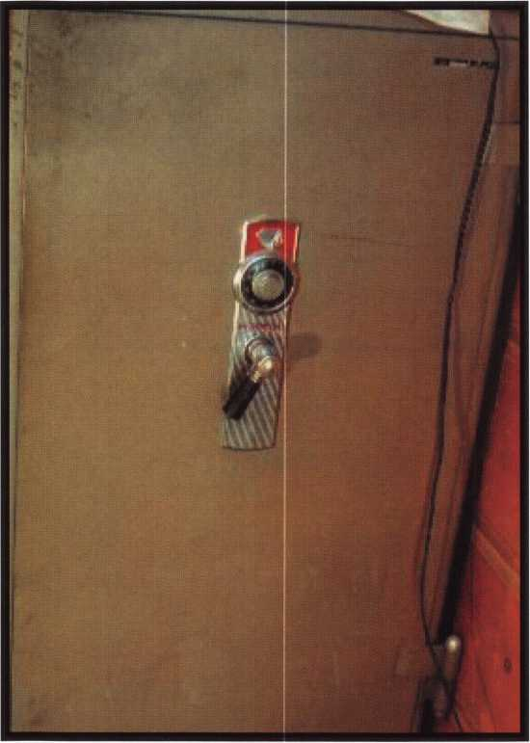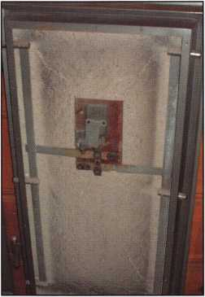

Twenty years ago, a gentleman passed away.

One daughter remembered the combination to  
his safe. She checked the safe a couple of times  
and then forgot the combo about io years ago.  
Now they want to close the estate, and it seems  
a couple of stocks and a deed were never changed  
out of his name. This is where I enter the story.  
“Can you open an old safe, and how much?” they  
asked. I said, “Of course, but I’ll need a little more  
info before pricing the opening.” I stopped by to  
look at the safe and take a couple of pictures with  
my digital camera. The safe was a Protectall fire  
safe. The first Protectall fire safe I’ve seen in per-  
son. We set the opening time for a week later.

Before opening any safe I haven’t seen before,

I consult my own library for information. I found several sources. This safe is in the “Illustrated Safes book of drawings” from Ed Willis. Dale Libby had written about an opening he had back in the late 80s in The National Locksmith. Milt Wolferseder wrote a couple of articles for the Locksmith Ledger, and Dave McOmie’s “The National Locksmith Guide to Safe Opening Vol. 2” has some excellent photos and information regarding this safe. The red background around the Indian head means this safe has an S-201 Mosler lock. If the background were black, it would have a CD-120 lock from Mosler. Dave recommended a drill point 1 1/2” down at 60. This will put you in an open area of the lock looking up and over a little at the fence. Looks like an easy opening. In my mailbox that night was the latest issue of Safe and Vault Technology. On the front cover was an old photo of a Protectall Fire safe booth at an early ALOA convention — what a coincidence. Just to verify, I posted pictures on the [www.savta.org](http://www.savta.org) web site. Chuck Caplinger responded with photos of the inside of the lock and Dave McOmie responded to confirm the drill point. He changed it slightly to 7/8” left 1 1/2” down, but either one would work just fine. He also suggested handle cam punching. I prefer to drill for the lock; it takes a little more talent and often the hole can be covered by a new dial and ring. I prefer to upgrade locks on

Keynotes • March 2003

**CONVENT ON**

**MARCH**

**24-29**

**BAHIA RESORT HOTEL •**

**CHNICIANS ASSOCIATION**

**TRADE SHOW**

**SAN DIEGO, CALIFORNIA**

GATE

**Future**

**CHNOLOGY**



these older units  
when possible  
(especially when  
I want to add  
the lock to my  
collection).

Opening time  
came and they  
gave me some pos-  
sible combinations  
to try One of the  
numbers she gave  
me was 98. I was

certain it was in the combo but I could not isolate  
which wheel it was. Anytime I tried to isolate it, it  
was shadowed by another wheel or wheels. Turns out  
the number was 95. All wheels right or left, “98” indi-  
cated a 2 number drop. As I worked, the customer  
and I were both getting cold, the safe was located in  
the unheated shed in the back yard. She asked if I

could just drill it and get the safe open. They didn’t want the safe anyway so if drilling would be quicker, “just get it open!” I played with the dial a little more before reaching for the drill. This safe drilled nicely with a StrongArm 1/4” in my 18 volt DeWalt cordless. Knowing I was going to enter the lock case in an open area allowed me to drill without concern of lurching into a wheel or gear. A few minutes later,

I lined the wheels up and turned the handle. The safe was unlocked.

The job I was hired to do was done. It’s up to the customer to open the safe. I picked up my tools and politely asked if I could take pictures of the inside of the safe door after she emptied the safe of the contents. As you can see the answer was yes. Not only yes to the pictures, but that she was going to check with her siblings to make sure none of them wanted the safe. They didn’t, and I now have the safe. One more lock for my collection.

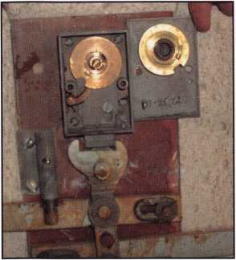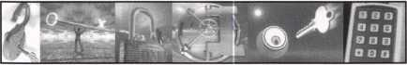

CLA TRADE SHOW & EDUCATION

TRADE SIHOW

**May** 3,2003

EDUCATIONAL PROGRAMS  
May **1**-**3,2003**

ONTARIO CONVENTION CENTER  
ONTARIO, CALIFORNIA



The California Locksmiths Association

1240 N. Jefferson Street, Suite G, Anaheim, CA 92807

(714) 632-6800 * FAX (714) 632-5405 * Email: [cla@speed.net](mailto:cla@speed.net)

TURfl ID

WHOLESALE SERVICE

In-Stock... SAFES FREE Freight Program Fax: 800-391-4553

800**-**848-9790

AMSEC FireKhg **Gatiall**HAYMAN MEIUNK \/lCTX>R

Keynotes • March 2003



Auailable as single  
modules (one CO and  
guidebook) or the full  
set (three CDs and  
three guidebooks).

Seruer uersions are  
also auailable!

**Self-Study Course**

**HLOfl**

**SPECIAL**

**SELF-STUDY GUIDEBOOK**

The ultimate training tool for locksmiths... **Nolu** there is a complete in-house training  
program auailable! Order the **Fundamentals of architectural Doors and Hardware Self**

**Study Course** three CD/guidebook series.

**To** order, call **(800)532-2562** or uiiiiLU.aloa.org.

**Get the award-winning  
*Fundamentals of architecture  
Doors and Hardware Self-Study  
Course* at a great price!**

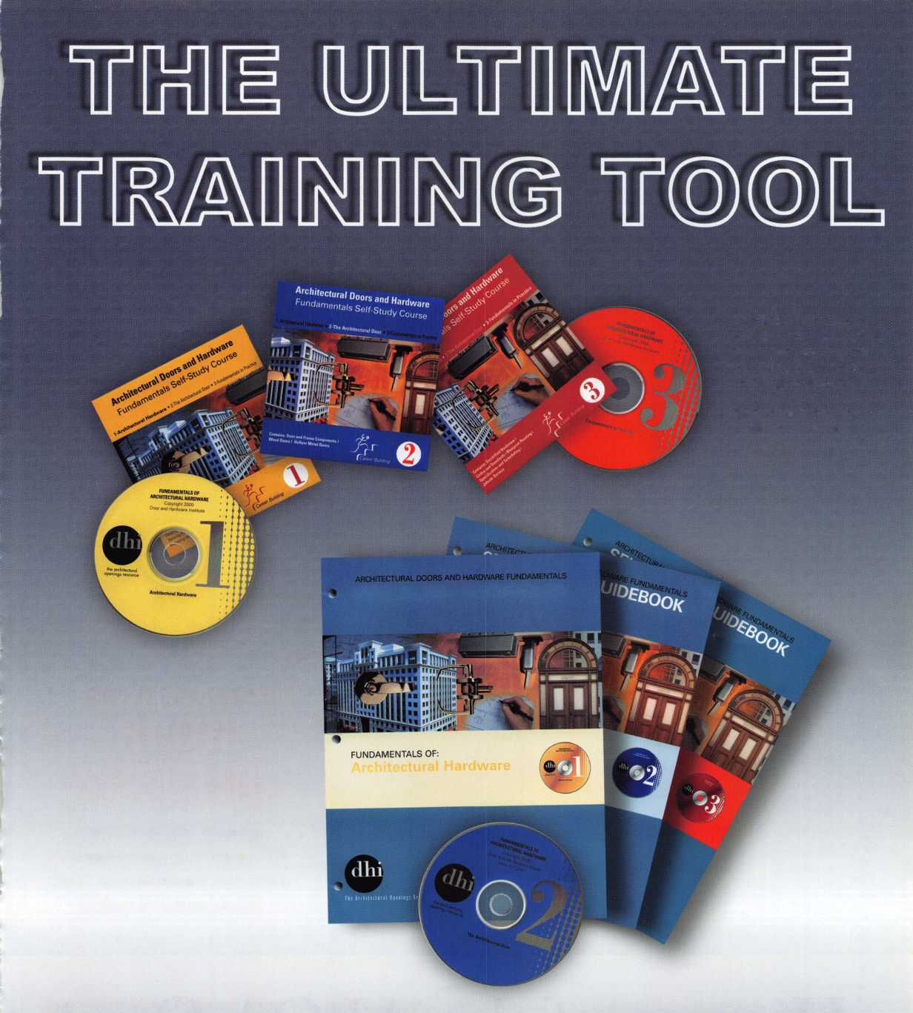

History of the ALOA Open

by Reg Moxley, CPL, Co-chairman, ALOA Open

Keynotes • March 2003

After the ALOA Board Meeting in 1985, [former ALOA VP] John Patterson and I were retired. As two VPs who still wanted to be affiliated with the ALOA Board, we discussed was life was going to be like not attending meetings all over the country We had talked about put­ting together a golf tournament for years, but neither of us had ever had the time to pursue this project. As time went on the afternoon after the meeting ended, we were able to come up with some pretty good ideas. With the input of another long-time member, Les Matthews, we laid the groundwork for the type of tournament we wanted.

We decided to use the newly formed ALOA Scholarship Foundation as our cause.

The next the we faced was how to finance this brainstorm. The last thing we wanted to do was go to the ALOA Board and ask for money. We kicked around some different ideas, but realized that this project needed some serious thought. We talked to a few of the Board mem­bers and the new president, Joe Jackman, and they were all in favor of an annual golf tournament, but no one talked about finances.

About two weeks later, Joe called and asked me to cover the Fall Education Meeting in Washington D.C. as an advisory, and I suggested I might want to check out local golf courses to see what was available for the 1986 ALOA Open. After a cou­ple of days of searching, I found a suitable course and the price was right. I went back home and report­ed to John what I had discovered and we decided to loan the ALOA Open Golf Classic $1500 to get started. This would give us money to buy hats and shirts for the first tour­nament. We also established the entry fee of $150 per player, thinking

that we could break  
even. It turned out that  
each participant got a  
hat, shirt, golf balls, tees  
and markers. Also  
included in the package  
was breakfast, green  
fees, cart, cocktail party,  
dinner and everyone  
received at least one  
prize. Les Matthews was  
able to procure enough  
prizes for all of our play-  
ers, and he did this for  
the first two years of the

ALOA Open. He was able to get  
donations of items like golf balls,  
shirts, visors and many other gifts  
that made our first two tournaments  
very successful. In addition, we were  
able to donate $1000 to the ALOA  
Scholarship Foundation when the  
smoke cleared after the very first  
ALOA Open.

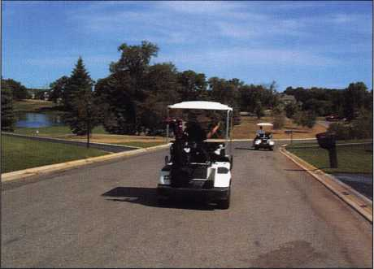

Thinking we were pros at running golf tournaments, we went to Dallas in 1987 at Stevens Park Golf Course. Although the course conditions were not exactly “up to par,” and the weather was an unbearable 100 degrees, the tournament was a great success again. This time, we were able to donate $1222.22 to the Scholarship Fund.

We now had two tournaments under our belt, so onto the Sahara Country Club in Las Vegas in 1988. We had finally come to the point where we needed some financial assistance. Well, as luck would have it, Yale Security Group wanted to sponsor the ALOA Open. Yale gave us the financial assistance we needed to put on a first class golf tournament. We were able to book in better courses, have better prizes and give even more money to the ALOA Scholarship Fund. Our goal was to donate $50,000 to the ALOA Scholarship Fund in 10 years.

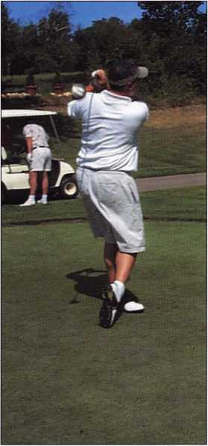

Keynotes • March 2003

Every dollar generated by the ALOA Open goes directly to the Scholarship Foundation.

Our next stop was Atlanta, GA. Yale sponsored the tournament again, this time at the Bobby Jones Golf Club. It was an excellent facility, super people and a great golf course. The only thing we didn’t do was consult the weather man. It rained all day - but the golfers were tough, and we made the best of it. Another ALOA Open under our belts.

I have to insert at this point that all of these events were sponsored by less than 50 players each year. My wife, Sue, and John’s wife, Gail, played a big part in most of these outings. They got sunburned, rained on, and still gave us support by oper­ating beverage carts and taking pic­tures. They also got some great videos of some of the unique hap­penings on a golf course.

The next three years (Anaheim, Chicago and Baltimore) were pretty smooth outings, and our numbers stayed about the same. However,

Yale kept increasing their support each year. In 1993, we went back to Chicago and were able to book Cog Hill Country Club, which is world famous for the Centel Western Open. This was by far our most suc­cessful tournament, as we had over 50 plays and we picked up some additional support from the industry. We had Yale as our main sponsor, and also Briggs and Stratton (golf balls), Fort Lock Corp. (shirts), Meilink Safe Co. (towels) and U Change Corp. (souvenir coffee cups).

This extra support allowed us to donate some $7500 to the ALOA Scholarship Fund in 1993.

Looking at 1994 and beyond, due to the increase in our number of play­ers, we created a Women’s Division and a Handicap Division for those with current handicap cards. We also have a unique scoring system called “Peoria Scoring” for large groups who don’t have an up-to-date handi­cap. This system allows everyone to shoot between 69 and 99. We award five trophies for this event, two for men, two for women and one combo for the Handicap Division. In addi­tion, all the winners’ names are put on a plaque, which hangs in the ALOA headquarters and comes to all conventions and is displayed at various locations.

This plaque was donated by the late Ken Stemig, Sr. Ken was a dedicated ALOA Open player who was in the elite group of golfers attending the first 10 tournaments. He even pre­sented all the 10-year people with a Sterling silver money clip commem­orating the occasion. Ken won the ALOA Open twice. He was an excel­lent golfer with a single digit handi­cap. Ken passed away in May of 2001. We now have a new plaque that was designed and created by Ken Stemig, Jr., in memory of his father. It’s official name is the “Ken Stemig Sr. Memorial Award.” Five golfers’ names will be added every year for the next 25 years. This

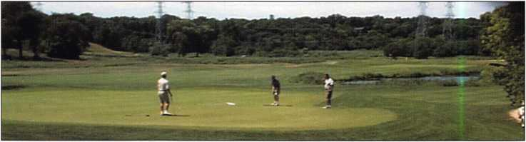

Keynotes • March 2003

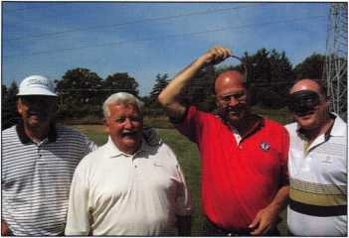

plaque represents how much Ken Stemig Sr. loved the ALOA Open Golf Classic and all for which it stands.

We have so much dedication in our all­volunteer committee. John Patterson, co-chairman, Mark Hokanson, vice chairman, and committee members Les Matthews and Bob Henke, past board members John Hubbard and Frank Hartung. These people get no reimbursement for anything, and they attend a meeting every year. Every dol­lar generated by the ALOA Open goes directly to the Scholarship Foundation. The interest earned off the principle goes to the education of needy students coming into the security profession each year.

Thanks to ALOA past president Stan Haney for his vision into the future.

In creating the ALOA Scholarship Foundation. Your ALOA Open over the last 17 years has generated over $200,000 to this great cause. Bring your clubs to Las Vegas or rent clubs Thursday, July 17, 2003 and join us.

The fee is still only $150 (tax deductible), payable to the ALOA Scholarship Foundation, Inc., and you’ll get more freebies than ever.

This is a win-win situation for players and for the charity it serves. You will have a fun-filled day and go home with more than you can carry. Help us con­tinue expanding this great tradition in Las Vegas this summer. See you on the links!

**From Nebs**

**For more information, visit us online: [www.professionalbusinessproducts.com](http://www.professionalbusinessproducts.com) or call 1-800-355-6322 for our catalog.**

*Professional*

*Business*

*Products*

**Professional** Business 1"^

**holds the Key to your**

**Savings! w**

p* a lock on spends

**call, order & SAVE.**

**Professional Business Products, your  
Associate ALOA Member, offers you  
lower prices, two color ALOA logo  
on standard forms and rebates to ALOA!**



SAFE CORPORATION

MANUFACTURES OF QUALITY DEPOSITORY SAFES AND CHESTS

DISTRIBUTING FROM

*WAREHOUSES IN* • LOS ANGLES, CA

* CHICAGO, IL
* GLASSBORO, NJ

A & B is now a stocking distributor

for Mutual Safes

featuring

uiui niy

■ I

AB-4-30-3S AB-9-2 WS 10-2

Chose from over 75 models in stock

We ship your order within

24 hours

See us

*ot [www.o-bsafecorp.com](http://www.o-bsafecorp.com)*800-253-1267  
Fax 856-863-1208

CALL FOR YOUR  
CATALOG TODAY



Keynotes • March 2003

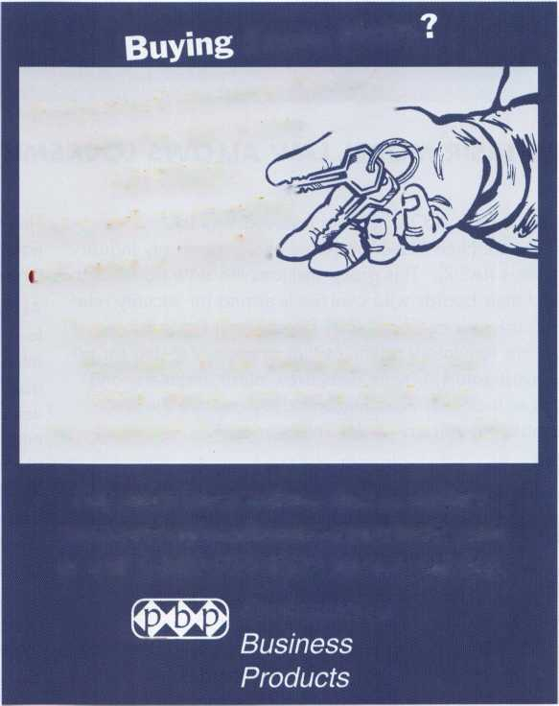

|  |  |  |  |  |
| --- | --- | --- | --- | --- |
| IjMBOTl | CD | 3 i s | 1 a 1 | CD  >  • |
|  | V.  u p | d a t | e |  |

NEW IASIR MODEL LAW ALLOWS LOCKSMITHS TO DO ACCESS CONTROL

Five years ago, ALOA became involved with the International (then National) Association of Security Industry Regulators (IASIR). This group includes the state administra­tor and their boards who oversee licensing for security relat­ed industries across the United States. Included in this group are regulatory agencies that oversee licensing for pri­vate investigators, private detectives, alarm installers, and yes, even locksmith licensing boards. These are the folks who make the rules once the law is passed.

In 1996, they adopted a "Model Electronic Security Licensing Act". This model law, actually written by NBFAA, regulated that no person shall sell, lease, rent, design, plan, install, monitor, maintain, repair, test or inspect "Electronic Security Systems" without first having obtained a license by the state. An Electronic Security System was broadly defined to include, solely or in combination: burglary detec­tion, fire detection, access control and/or closed circuit tele­vision. This model law was used in Alabama, Ohio, Texas, Mississippi and other states to preclude locksmiths from installing any type of access control work. In the Model Law each company would have to have a "Qualifying Agent" with a minimum three years experience in an Electronic Security System Company (i.e. Alarm Company). This alone, prevented locksmiths from access control installation.

This sparked an Industry Position Paper to support fair and equitable licensing, and was signed by over 1 1 8 manufac­turers and distributors.

ALOA joined IASIR with a purpose: to change that model law to make it favorable to locksmiths. After five years of intense negotiations with NBFAA, we have come to a work­able solution. Under the new model law, a company is licensed as a "Security Systems Company" and each employee is registered according to their specialty (burglar alarm technician, locksmith, access control technician). The law only defines the different areas of expertise, creates a Board, gives broad authority to that board to develop rules, creates a state agency to oversee the administrative process, has a reciprocity clause and exempts current state laws. ALOA made sure that locksmiths are included on this board so any rules pertaining to locksmiths are prescribed by locksmiths.

This model law is ideal for states without any alarm or lock­smith licensing laws. It may also be easily modified to those states wishing to introduce a locksmith licensing law only.

For a copy of the model law, visit ALOA's improved legisla­tive website at: [www.aloa.org/leg](http://www.aloa.org/leg).

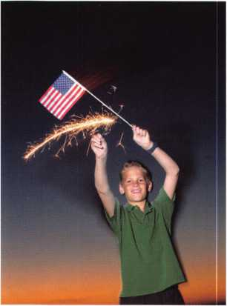

JOIN THE LEGISLATIVE ACTION NETWORK TODAY!

As we continue to expand our resources and become more competitive in the legisla­tive arena, we need the monetary resources to match our successes. You can help with as little as $24.95 to the Legislative Fund. This is only the minimum that we are asking, and encourage you to give more if you can. Those that contribute will be given a Legislative Action Network Member kit to use in their grass roots efforts. Members who donate $100 or more become Legislative Action Network Council members, and enjoy the following extra benefits: a reserved place of distinction on the special LAN Council; Discounts on ALOA bookstore items; 10 % rebate on all ACE classes; Complimentary Legislative Convention merchandise. Join today online at [www.aloa.org/news/lan.htm](http://www.aloa.org/news/lan.htm).

Keynotes • March 2003

CONNECTICUT SB 14

SUMMARY: Requires the licensing of locksmiths.

STATUS: 01/08/2003 INTRODUCED and Referred to General Laws

Committee

The text of the bill has not been released from legislative serv­ices, but has been assigned a bill number.

A copy of this bill can be found at:

<http://www.cga.state.ct.us/2003/tob/s/2003SB-00014->

R00-SB.htm

ILLINOIS HB488

SUMMARY: Amends the Private Detective, Private Alarm, Private Security, and Locksmith Act of 1993. Makes a technical change in a Section concerning temporarily suspending a license.

STATUS: 01/30/2003 INTRODUCED and Referred to House

Committee on Rules.

This is a "shell" bill to introduce the revised legislation A copy of this bill can be found at:

<http://www.legis.state.il.us/legislation/93/HB/PDF/09300H>

B0488lv.pdf

INDIANA HB1946

SUMMARY: Establishes a voluntary registration program for locksmiths.

STATUS: 01/23/2003 INTRODUCED and Referred to House

Committee on Commerce.

A copy of this bill can be found at: [http://www.in.gov/leg- islative/bills/2003/IN/IN](http://www.in.gov/leg-islative/bills/2003/IN/IN) 1946.1 .html

MISSISSIPPI SB2367

SUMMARY: Burglar alarms; license and regulate installation.

STATUS: 02/04/2003 Died in Committee.

The definition of Burglar Alarm reads, "a security system com­prised of an interconnected series of alarm devices or compo­nents, including systems interconnected with radio frequency signals, which emits an audible, visual or electronic signal indicating an alarm condition and providing a warning of intrusion which is sent to a central station and requires a response by an emergency team such as police or fire personnel.

A copy of this bill can be found at:

<http://billstatus.ls.state.ms.us/documents/2003/html/SB/230>

0-2399/SB2367IN.htm

NEVADA SB39

SUMMARY: Requires landlord to change entry locks of dwelling unit

before delivering possession of dwelling unit to new tenant.

STATUS: 02/03/2003 Introduced

02/03/2003 To Senate Committee on Judiciary

A copy of this bill can be found at: <http://www.leg.state.nv.us/72nd/bills/SB/SB39.html>

NEW YORK AB2646

SUMMARY: Establishes security requirements to be fulfilled by owners of multiple dwelling units including deadbolt locks, window pins, adequate lighting, solid core doors, intercoms and optical viewers; provides requirements for each such security measure.

STATUS: 01/29/2003 INTRODUCED and Referred to Assembly

Committee on Housing.

A copy of this bill can be found at: <http://assembly.state.ny>. us/leg/?bn=A02646&sh=t

NORTH DAKOTA HB1159

SUMMARY: Relates to the jurisdiction of the private investigative and secu­rity board. Gives vague definition on what constitutes "securi­ty services"

STATUS: 01/07/2003 INTRODUCED and Referred to Industry,

Business and Labor Committee

01/14/2003 First Reading

A copy of this bill can be found at:

<http://www.state.nd.us/lr/assembly/582003/bill_text/DQS>

G0100.pdf

SOUTH CAROLINA SB 186

SUMMARY: Provides certain instances in which dead bolt locks requiring a key for operation on both sides may be used on exit doors.

STATUS: 01/14/2003 INTRODUCED and Referred to Committee on

Judiciary

A copy of this bill can be found at:

<http://www.lpitr.state.sc.us/sessl> 15_20032004/bills/l 86.htm

TENNNESEE SB188

SUMMARY: Requires that all alarm system contractor employees who sell, install or repair alarm systems, including closed circuit televi­sion systems, shall take and successfully complete the National Burglar and Fire Alarm Association Level 1 or equivalent training.

STATUS: 02/06/2003 INTRODUCED

A copy of this bill can be found at:

<http://www.legislature.state.tn.us/bills/currentga/BILL/SB01> 8 8.pdf

Keynotes • March 2003

3

ALOA Complaint Form

The proposed “The Motor Vehicle Owner's Right to Repair Act” ensures the right of a motor vehicle owner to obtain all information required for the diagnosis, service, and repair of the motor vehicle in a timely, affordable, and reliable manner. Although the bill does not specifically say what information must be pro­vided, ALOA is working with the after-market industry to ensure that the information you need to service any vehicle is released. This complaint form provides ALOA with information that will identify any prob­lems locksmiths may encounter through servicing their customers during a vehicle lockout/re-keying/originat- ing keys incident. We will use this information to make our case to the automobile manufacturers and to Congress on why this bill is important to locksmiths.

Locksmith Name:ALOA#

Shop Name:

Date/Time Received Customer Call:

Customer Name: Phone:

Vehicle Manufacturer: Type:Year:

Briefly describe incident, of why you were unable to service the customer, including any inconvenience the customer experienced:

Return completed form by mail or fax to:

Tim McMullen, Director of Public Policy

ALOA

3003 Live Oak St.

Dallas, TX 75204 Fax: (214) 827-1810 (make copies as needed)

core



Lockmasters Hires Young

Lockmasters, Inc., recently added automotive guru Steve Young to the organization.

"The addition of Steve, and the industry expertise he represents, is a perfect complement to our long history of product and training experience," said Lockmasters pres­ident, Mark Miller. "Steve is regarded as an industry expert and is widely respected by everyone who has had the privilege of work­ing with or being trained by him. This great opportunity will afford Steve additional time to develop new car-opening tools, manuals, videos, and even a new line of DVD products."

LA GARD Appoints Dan Sparks as South/Midwest

To maximize the service of customer accounts, LA GARD announces the appointment of Dan Sparks, as their South/Midwest Regional Sales Manager. With the addition of Sparks, LA GARD now has three marketing territories in the U.S.

Sparks has thirty-three years of experience in the security industry. In addition he has worked closely with LA GARD products for the last twenty years as the CAD Application Specialist and Project Leader for Diebold, LA GARDiS largest customer.

"Because of Danis experience and knowledge of LA GARD prod­ucts, we feel he can service the South/Midwest Region effectively and provide LA GARD customers with the highest quality of cus­tomer support."said Susan Papa, Vice President of Sales and Marketing for LA GARD.

In conjunction with the hiring of Sparks, LA GARD has realigned their customer support structure by dividing the country into three sections. George Chenarides is now the Regional Sales Manager in the West, and Larry Cutter will represent LA GARD in the Northeast. Sparks will handle the remainder of the nation.

For more information about LA GARD products, please call (310) 325-5670, or request information through LA GARDiS 24-hour Fax-On-Demand toll-free request line at (877) LAGARD2 or 524- 2732. The Fax-On-Demand request line allows a caller to receive information on LA GARDiS product line as well as operating, pro­gramming and distributor information through their fax machine almost instantly, 24-hours a day. Or visit LA GARDiS Website at [www.lagard.com](http://www.lagard.com).

New Certifications

Shepherd, Derrick E., CRL Wynn, John M., CRL Hines, John E., CRL

Let Us Know!

If you have an opinion to offer on ALOA, the state of the industry, or life in general, we want to know about it! Submissions to the "Mailbox" section of Keynotes are printed on a space-available basis. Write to: "Letters to the Editor"; ALOA;

3003 Live Oak Street; Dallas, TX, 75240; FAX 214/827-1 810; e-mail: [editor@aloa.org](mailto:editor@aloa.org).

Need Help?

At ALOA, we want to make sure you are getting as much bang for your membership dues buck as we are able to give you. If you have had problems getting membership services, or have a ques­tion regarding member services, please contact Bill Gibson, execu­tive director, at 800/532-2562, or e-mail: [charlie@aloa.org](mailto:charlie@aloa.org).

ALOA Grievance Policy

According to the Bylaws of the Associated Locksmiths of America, Inc., Article III, G. Section 6:

A member may be censured, suspended or removed by a two- thirds vote of the Board if he has violated

the Charter, Code of Ethics or the ALOA Bylaws. Charges must be presented in writing to the Grievance Committee. Action shall occur only

after the member complained against has been

given an opportunity to for defense before the Board. There is the

right of appeal.

To file a grievance, the official ALOA Grievance form [available on our Web site, [www.aloa.org](http://www.aloa.org), or by calling toll free 800/532- ALOA] must be filled out, signed and returned to the Associated Locksmiths of America, Inc., before any action can be taken regarding your complaint. The form, when completed and returned, will be forwarded to the entire Grievance Committee and read at their next meeting.

The ALOA Grievance Committee is the direct link between the membership and the Board of Directors, and is available to medi­ate disputes between ALOA members and disputes that involve other persons or companies. Be advised that personal feuds and/or vendettas of unsubstantiated accusations will be rejected by the committee. The person you have filed a grievance against will be notified of the nature of the complaint and will be invited to respond.

For additional information, contact membership services toll free at 800/532-ALOA, or by e-mail at [membership@aloa.org](mailto:membership@aloa.org).

Keynotes • March 2003



EMPLOYMENT

LOCKSMITH NEEDED FOR A CONTRACT ASSIGNMENT

A nationwide security services provider is looking for a locksmith to perform basic assignments. This will include the installation and replacing of locks at cus­tomer sites. Strong mechanical aptitude and proficien­cy with hand tools required. This individual must be a fast learner and have the ability to complete assigned tasks with minimum supervision. Must have a valid drivers license. Experience as a locksmith or apprentice would be helpful.

Location: New York metropolitan area

Scheduled Hours: Typical business hours, Monday through Friday. There may be some occasional over­time based on projects needs.

Travel: Local travel throughout the 5 boroughs and Nassau / Suffolk.

Start Date / End Date: Interviews in early February with the client and a project start date of February 24th (approx.)

Additional Information: All candidates must have ver­ifiable work experience. Criminal and credit back­ground checks will be conducted.

Contact Information: Lori Useche, Technical Recruiter, IT Network Consultants, Inc., (631) 757-2400 ext.228, Fax: (631) 757-8605 [Luseche@itnc-usa.com](mailto:Luseche@itnc-usa.com) • [www.itnc-usa.com](http://www.itnc-usa.com)

LOCKSMITH/BUSINESS PARTNER

Growing locksmith company in Edmonton, Alberta, Canada (and surrounding area) requires a lock­smith/business partner. We are looking for a hard working, dedicated individual with a desire to further his/her career. Please send or fax your resume to:

Robert Richard • Knight Lock and Safe • Box 21043 Leduc, Alberta T9E 6R4 • Fax (780) 980-8283 e-mail: [knightlocksnsafe@aol.com](mailto:knightlocksnsafe@aol.com)

LOCKSMITH WANTED

NW Pennsylvania. Rapidly growing company. New retail store. Looking for locksmith for outside service. Mostly commercial work. Safe servicing and access control experience a plus. If you enjoy outdoor sports of all kinds, including hunting and fishing, this is the place to live. Contact: Uhlig Lock and Safe

16325 Conneaut Lake Rd.

Meadville, PA 16335 814/724-2255 • (814) 724-1687 (fax) lockdoctor@alltell. net

LOCKSMITH WANTED

Busy shop in Woburn, MA, has immediate opening for a self-motivated, ambitious locksmiths. We have a large customer database for automotive, AAA, com­mercial and residential accounts. Applicants with own van and tools are guaranteed 50 percent commis­sion. We supply more expensive tools, such as TCL, NGS, other transponder programming tools, etc. No waiting to get paid, no having to be available 24 hours a day to make a good week's pay, and no worrying about the enormous bills associated with being self-employed. (Yellow pages, direct mail, answering services, pagers, office supplies, office payroll, rent, heat, electric, and other bills that can add up to more than your gross!) If you feel you're a great locksmith and want to be rewarded for your experience, this is for you. If you currently own your own business now and don't want all the headaches of being in charge of advertising, human resources, customer relations, payroll, accounts, receivable, accounts payable, dispatch, etc., let us know if you want to be a partner. Too many great locksmiths go out of business for trying to do it all. If you feel this is an opportunity you would like to know more about, send resume to:

Locks & Keys, Inc. • P.O. Box 222

Woburn, MA 01801

Or call John at (781) 933-9999

ACCOUNT EXECUTIVE WANTED

We are seeking an energetic, experienced sales pro­fessional to join our rapidly growing team. Candidate must possess a strong background in commercial hardware as well as electronic access control, (cctv and alarm experience is a plus!). Minimum 5 years sales experience required. We offer: Top wages, commission, expense account, 401k, paid vacations and holiday, hospitalization.

E-MAIL resume to: [rmesnick@bass-security.com](mailto:rmesnick@bass-security.com) <mail- to:[rmesnick@bass-security.com](mailto:rmesnick@bass-security.com)> or phone-216-755- 1200 ext# 128.

STOP LOOKING!!!!! EXPERIENCED TECHNICIANS WANTED

Lock into your future now! If you are experienced, intelligent, and desire a secure future, come join our team. We are a full service commercial/residential security service (locks,keys,safes,cctv,access control, door related hardware). We offer: sign on bonus, top wages, company vehicle, 401 k, paid vacation, paid holidays, new uniforms, cross training, and job satisfaction. We are looking for the best tech's, who are ready to be treated and compensated as profes­sionals. Bass Security Services, Inc. • Ph#216-755- 1200 ex.#l28 • Fax#216-755-1220 • E-MAIL/ [rmesnick@bass-security.com](mailto:rmesnick@bass-security.com)

AUTOMOTIVE LOCKSMITH WANTED

Relocate to South Florida and throw away your deadbolts and three keys for a dollar.

We run over 300 calls per week. You must own a truck with tools and code equipment to cut all foreign and domestic keys. You can earn $800 to $1500 per week. South Florida Lock and Safe. 800/928-2926. Please if no truck or tools, no calls.

Classified Advertising Policy

Classified advertising space is provided free of charge to ALOA members, and fora fee of $.60 per word, $15 minimum for non-members. Classified ads may be used to advertise used  
merchandise and overstocked items for sale, "wanted to buy" items, business opportunities, employment opportunities/positions wanted and the like. Members or non-members wishing to  
advertise services or new merchandise for sale may purchase a "Commercial Classified Ad," for a fee of $1.30 per word, with a minimum of $40. Each ad will run for two issues. For  
blind boxes there is a $5 charge to members and non-members. All ads must be submitted in writing to the ALOA office by the fifteenth of the month, two months prior to issue date. Send  
to Keynotes Classifieds, 3003 Live Oak St., Dallas TX 75204-6186. ALOA reserves the right to refuse any classified advertisement that it deems inappropriate according to the stated pur-  
pose of the classified advertising section.

Keynotes • March 2003

SUPERVISOR, SECURITY SYSTEMS

Emory is one of the five largest private employers in the Atlanta metro area and the largest employer in Dekalb County. The University is admired worldwide for academic, patient care, research and technologi­cal excellence. As an Emory employee, you are part of a community which values diversity, education, training, and personal development. Creativity and innovative ideas are nourished and rewarded. We invite you to share in a unique culture of education, research and health care.

We currently have a great opportunity for a Supervisor, Security Systems in our Security Shop. They will Provide locksmith, alarms, control systems and security system services including installing, repairing, inspecting, and recombination mechanical, electro-mechanical, electronic locking and monitoring devices and door hardware. Performs diagnostic tests on digital, key pad and card-locking, and other electronic locking systems for the University.

MINIMUM QUALIFICATIONS: High school diploma or equivalent. Five years combination locksmith and electronics/security systems experience, including two years supervisor experience. Thorough journeyman level knowledge and skills in mechanical, electro­mechanical, electronic locking and monitoring devices and door hardware. Journeyman level skill in maintenance and repair procedures including pre­ventive maintenance, breakdown repair and trou­bleshooting, construction, installation and fabrication techniques typical in trade; perform mathematical computations of trade. Knowledge of ADA specifica­tions and proper use and maintenance of hand and power tools, test equipment and electronics equip­ment related to job functions. Valid Georgia driver's license and insurable driving record. Some positions within this classification may require the ability to lift 50 pounds and to bend, stoop and twist.

Departmental Information/Preferred Qualifications: Ideal candidate will have a high degree of organiza­tional, communication, customer service, and good leadership skills.

We offer competitive salaries and world-class benefits including major medical/dental/vision/life insurance, disability insurance, paid holidays/vacation, tuition assistance, a generous employer matching 403(b) retirement plan and courtesy scholarships for family members and same-sex domestic partners. For more information about our benefits, please visit our web­site at: <http://emory.hr.emory.edu/benefits.nsf>

A career with Emory University affords a level of prestige and stability not found in many Atlanta Employers of Choice. We invite you to become a part of the Origins of Excellence!

Please submit your resume via (online from) the Emory Careers Website at

emory.hr.emory.edu/careers.nsf or by mail at Emory University, 1762 Clifton Road, Atlanta, GA, 30322. Phone: 404.727.7611 Fax: 404.727.1922 Please reference Job posting 136542 when applying.

Emory University is an AA/EOE Employer

BUSINESS FOR SALE

BUSINESS FOR SALE

32 years. Need to retire. Will sell business with or without 1 800 square foot building on major down­town street. Only locksmith in county. Growing west Texas area. Call 915/336-3278 and ask for Dean.

BUSINESS FOR SALE

Looking to relocate to sunny Arizona. Established in same location for over 14 years. Profitable Lock & Safe business with service and retail location.

Good client base. Reasonably price to right person. E-mail inquiries to [Lockbizaz@aol.com](mailto:Lockbizaz@aol.com) or fax to (602) 870-8505.

BUSINESS FOR SALE

Locksmith glass and screen business located in fast growing NW Arizona between Kingman, AZ, and Laughlin, NV. Well-equipped 1995 Dodge van and leased shop on busy highway. All equipment and inventory included. $48,900 takes all. Health demands retirement. Call (928) 565-2294 or e-mail at [lmburks@ctaz.com](mailto:lmburks@ctaz.com).

WANTED TO BUY/SELL

NEED AUTO INFO?

Do you do exotic autos? If you are called to provide keys for a Panoz Espirante, Here is contact info for the company - they provided key codes, transponder codes and are very helpful: Panoz Auto Development Company

1101 Highway 124 • Hoschton, Georgia 30548 Tel: (770) 867-4796 • Toll Free: 1-888-GOPANOZ (467-2660) • Fax: (770) 307-1714 E-mail: [panozauto@panozauto.com](mailto:panozauto@panozauto.com)

FOR SALE

5 Schlage A53PD ORB 626 Entry locksets @ $20 each

3 US1760BF DL door closers @ $50 each 2 US1735 AL door closers @ $50 each 1 US 1703 DL door closer @ $25 1 US 1743 DL door closer @ $30 1 US 1744 DL door closer @ $30 1 Monarch #19 Rim Exit Panel Device 36" AL @ $75 1 US2870 AL Rim Panic Device @ $100

Contact: Builders Hardware Sales and Service • Phone: (610) 495-5465 e-mail: [barlocks@juno.com](mailto:barlocks@juno.com)

BACK ISSUES!

FOR SALE: Assorted Issues of locksmithing publications including Keynotes, Locksmith Ledger,

The National Locksmith, Reeds, etc. dating from the early 1980s. Contact Richard at 281-931-7525 to make offer.

FOR SALE

Fort Lock Tubular Model KM#7, llco Model 21 83HM, llco Model 2585, Jenson Micro Dial Model 1275. Plus, HUGE octagon rotating cabinet loaded with merchandise. ALL PRICED TO SELL! 847-251-2543. Central Time- evening calls are best. Ask for Jake

WHOLESALE SAFE DEPOSIT LOCKS

Allied, Diebold, Herrin Hall & Mavin, llco, Lefabure, Mosler, Precision, S&G, Security Corp., Yale. Locks from early 1900s to current. Call or e-mail for lock type and pricing sheet. Quantity discouts. Call WBI (888)329-7265 or (954)484-2404 or [sales@wbi.us](mailto:sales@wbi.us).

DISTRIBUTOR WANTED

Veteran manufacturer (since 1935) of security prod­ucts for vehicle protection against theft is looking for agents and distributors of our products. We manufac­ture mechanical parking posts, steel barriers and "Denver boots" (wheel clamping against theft devices). Please contact Kantero Israel:

Fax 972-3-6837228, or e-mail: i.k.a.@hotmail.co.il

LIQUIDATION SALE!

By appointment only. After 55 years of doing busi­ness, A-Armitage Locksmiths is closing its doors! Merchandise, lock supplies, key machines and much more! Most items are being offered 30 percent below wholesale prices! All sales final. Please bring a copy of your Illinois tax exempt registration to purchase the goods.

Weekday appointments call (773) 339-4535 Weekend appointments call (815) 238-0800

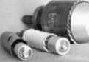

Hole Saw § Alignment Guides

No More Plywood, "C" Clamps, or Jigs  
Needed to Over Bore Existing Holes

’ Our Guides let you over bore existing holes that meas. 5/8”, 3/4” & 1-1/2” diameter 1 They work on wood as well as metal 1 Itoo small sizes ideal for desks and cabinets 1 Purchase in sets or individually

* Visa, MC, Amex, Discover
* MONEY-BACK GUARANTEE

**Tri-City Lock Company**

Daniel D. Mello, Owner-Locksmith  
Groveland, CA

209 962 4692 • 209 962 4910 FAX E-mail: [slmello@mlode.com](mailto:slmello@mlode.com) **[www.tricitylock.com](http://www.tricitylock.com)**

Keynotes • March 2003



Distributor

ADI Inc.

Phone: 631-692-1000 Fax: 631-692-3011

Accredited Lock Supply Co.

Phone: 201-865-5015 Fax: 201-865-0030 [www.acclock.com](http://www.acclock.com)

Ace Lock & Security Supply

Phone: 908-688-7666 Fax: 908-688-2442 [www.acelock.com](http://www.acelock.com)

Action Hardware Inc.

Phone: 800-662-6695 Fax: 800-930-2329

Andrews Wholesale Lock Supply

Phone: 717-272-7422 Fax: 717-274-8659 [www.andrewslock.com](http://www.andrewslock.com)

Boyle & Chase Inc.

Phone: 800-325-2530 Fax: 800-205-3500 [www.boyleandchase.com](http://www.boyleandchase.com)

Chinrose International

Phone: 503-357-7553 Fax: 503-357-5522 [www.chinrose.com](http://www.chinrose.com)

Clark Security Products

Phone: 800-854-2088 Fax: 619-974-5284 [www.clarksecurity.com](http://www.clarksecurity.com)

Cook's Building Specialties

Phone: 505-883-5701 Fax: 505-883-5704

Dire's Lock & Key Company

Phone: 303-294-0176 Fax: 303-294-0198

Direct Security Supply, Inc.

Phone: 800-252-5757 Fax: 800-452-8600

Doyle Security Products

Phone: 800-333-6953 Fax: 612-521-0166 [www.doylesecurity.com](http://www.doylesecurity.com)

Dugmore and Duncan, Inc.

Phone: 888-384-6673 Fax: 888-329-3846

E. L. Reinhardt Co., Inc.

Phone: 800-328-131 1 Fax: 651-481-0166 [www.elreinhardt.com](http://www.elreinhardt.com)

Ewert Wholesale Hardware

Phone: 800-451-0200 Fax: 708-597-0881

Fairway Supply, Inc.

Phone: 214-350-0021 Fax: 214-352-4299 [www.fairwaysupply.com](http://www.fairwaysupply.com)

Foley-Belsaw Company

Phone: 800-821-3452 Fax: 816-483-5010 [www.foley-belsaw.com](http://www.foley-belsaw.com)

Fried Brothers Inc.

Phone: 800-523-2924 Fax: 215-592-1255 [www.fbisecurity.com](http://www.fbisecurity.com)

H L Flake Co.

Phone: 800-231-4105 Fax: 713-926-3399 [www.hlflake.com](http://www.hlflake.com)

H.S. & S. Wholesale Distrib.

Phone: 313-342-6777 Fax: 313-342-7580

Hans Johnsen Company

Phone: 214-879-1550 Fax: 214-879-1530 [www.hjc.com](http://www.hjc.com)

Hardware Agencies, Ltd.

Phone: 416-462-1921 [www.hardwareagencies.com](http://www.hardwareagencies.com)

IDN Incorporated

Phone: 817-421-5470 Fax: 817-421-5468 [www.idn-inc.com](http://www.idn-inc.com)

Intermountain Lock & Supply

Phone: 800-453-5386 Fax: 801-485-7205 [www.intermountainlock.com](http://www.intermountainlock.com)

Jo Van Distributors

Phone:416-752-2238 Fax: 416-752-7282 [www.jovanlock.com](http://www.jovanlock.com)

KeylessRide

Phone: 877-619-3136 Fax: 409-216-5058 [www.keylessride.com](http://www.keylessride.com)

Lockmasters, Inc.

Phone: 859-885-6041 Fax: 859-885-7093 [www.lockmasters.com](http://www.lockmasters.com)

Locks Company

Phone: 800-288-0801 Fax: 305-949-3619

Locksmith Ledger International

Phone: 770-886-0800 Fax: 770-889-7703 [www.lledger.com](http://www.lledger.com)

M. Zion Company

Phone: 212-349-8677 Fax: 212-964-0495 [www.mzion.com](http://www.mzion.com)

McDonald Dash Locksmith Supply

Phone: 800-238-7541 Fax: 901-366-0005 [www.mcdonalddash.com](http://www.mcdonalddash.com)

McManus Locksmith Supply, Inc.

Phone: 704-333-9112 Fax: 704-332-8664 Monaco Lock Co.

Phone: 800-526-6094 Fax: 800-845-5625 [www.monacolock.com](http://www.monacolock.com)

Omaha Wholesale Hardware

Phone: 800-238-4566 Fax: 402-444-1664 [www.omahawh.com](http://www.omahawh.com)

Phoenix Safe International LLC

Phone: 765-483-0954 Fax: 765-483-0962 [www.phoenixsafeusa.com](http://www.phoenixsafeusa.com)

Professional Business Products

Phone: 248-360-3979

Fax: 248-360-3982

[www.professionalbusinessproducts](http://www.professionalbusinessproducts).

RA-Lock Company

Phone: 972-775-6301 Fax: 972-775-6316 [www.ralock.com](http://www.ralock.com)

SecureRite.Com

Phone: 800-241-3930 Fax: 858-974-5269 [www.SecureRite.Corn](http://www.SecureRite.Corn)

Security House

Phone: 905-669-5300 Fax: 905-660-6313 [www.securityhouselock.com](http://www.securityhouselock.com)

Security Lock Distributors

Phone: 800-847-5625 Fax: 800-878-6400 [www.securadealer.com](http://www.securadealer.com)

Sentry Security Fasteners

Phone: 309-693-2800 Fax: 800-693-2872

Somerset Security Products

Phone: 800-881-5206 Fax: 800-206-9949

Southern Lock and Supply Co.

Phone: 727-541-5536 Fax: 727-544-8278 [www.southernlock.com](http://www.southernlock.com)

Stone & Berg Wholesale

Phone: 800-225-7405 Fax: 800-535-5625

The Locksmith Store Inc.

Phone: 847-364-5111 Fax: 847-364-5125 [www.locksmithstore.com](http://www.locksmithstore.com)

Timemaster Inc.

Phone: 859-259-1878 Fax: 859-255-0298 [www.time-master.com](http://www.time-master.com)

Top Notch Distributors, Inc.

Phone: 800-233-4210 Fax: 800-854-4146 [www.4topnotch.com](http://www.4topnotch.com)

U.S. Lock Corp.

Phone: 800-925-5000 Fax: 800-338-5625 [www.uslock.com](http://www.uslock.com)

Manufacturer

A & B Safe Corporation

Phone: 800-253-1267 Fax: 856-863-1208 [www.a-bsafecorp.com](http://www.a-bsafecorp.com)

ABUS Lock Company

Phone: 800-352-2287 Fax: 602-516-9934 [www.abus.com](http://www.abus.com)

Abloy Door Security

Phone: 800-465-5761 Fax: 514-335-0430 [www.abloy.com](http://www.abloy.com)

Adams Rite Mfg Company

Phone: 800-872-3267 Fax: 800-232-7329 [www.adamsrite.com](http://www.adamsrite.com)

Adesco Safe Mfg. Company

Phone: 800-821-6803 Fax: 562-408-6427 [www.adesco.com](http://www.adesco.com)

Adrian Steel Company

Phone: 800-677-2726 Fax: 517-265-5834 [www.adriansteel.com](http://www.adriansteel.com)

Alarm Lock Systems Inc.

Phone: 800-252-5625 Fax: 516-789-3383 [www.alarmlock.com](http://www.alarmlock.com)

All Five Tool Company, Inc.

Phone: 860-583-1691 Fax: 860-583-4516 [www.all5tool.com](http://www.all5tool.com)

American Lock Company

Phone: 708-534-2000 Fax: 708-534-0531 [www.armericanlock.com](http://www.armericanlock.com)

American Security Products

Phone: 909-685-9680X1083 Fax: 909-685-9685 [www.amsecusa.com](http://www.amsecusa.com)

BWD Automotive

Phone: 334-872-6524 Fax: 334-874-601 1 [www.bwdautomotive.com](http://www.bwdautomotive.com)

Baldwin Hardware

Phone: 610-796-4012 Fax: 610-796-4493 [www.baldwinhardware.com](http://www.baldwinhardware.com)

Be-Tech Security Systems Ltd,

Phone: 852-231-67447 www. be-tec h. co m. h k

Buddy Products

Phone: 800-886-8688 Fax: 312-733-8356 [www.buddyproducts.com](http://www.buddyproducts.com)

COMPX Security Products

Phone: 864-297-6655 Fax: 864-297-9987 [www.nclnet.com](http://www.nclnet.com)



Keynotes • March 2003

associate

members

Curtis Industries, A Barnes Distr.

Phone: 800-555-5397 Fax: 800-867-6020 [www.curtisindustries.com](http://www.curtisindustries.com)

D&D Technologies (USA), Inc.

Phone: 714-677-1300X292 Fax: 714-677-1299 [www.ddtechusa.com](http://www.ddtechusa.com)

DETEX Corporation

Phone: 800-729-3839 Fax: 830-620-671 1 [www.detex.com](http://www.detex.com)

DORMA Architectural Hardware

Phone: 717-336-3881 Fax: 717-336-3500 [www.dorma-usa.com](http://www.dorma-usa.com)

Don-Jo Manufacturing, Inc.

Phone: 978-422-3213 Fax: 978-422-3467 [www.don-jo.com](http://www.don-jo.com)

Door Controls International

Phone: 800-742-3634 Fax: 800-742-0410 [www.doorcontrols.com](http://www.doorcontrols.com)

ESP Lock Products Inc.

Phone: 978-562-3481 Fax: 978-562-9859

FireKing Security Products

Phone: 800-457-2424 Fax: 800-896-6606 [www.fireking.com](http://www.fireking.com)

HES, Inc.

Phone: 623-582-4626 Fax: 623-582-4641 [www.hesinnovations.com](http://www.hesinnovations.com)

HPC, Inc.

Phone: 847-671-6280 Fax: 847-671-6343 [www.hpcworld.com](http://www.hpcworld.com)

Hongtai Lock Co. Ltd.

Phone: 137-238-1414 Fax: 208-793-3856

INTELLIKEY Corp.

Phone: 800-226-0703 Fax: 321-724-0811 [www.intellikey.com](http://www.intellikey.com)

Jet Hardware Mfg., Co.

Phone: 718-257-9600 Fax: 71 8-257-0973 www. j etkey s .com

KABA High Security Locks

Phone: 860-621-3601 Fax: 860-621-9727 [www.kabausa.com](http://www.kabausa.com)

KABA ILCO Corp.

Phone: 252-446-3321 Fax: 252-446-4702 [www.kaba-ilco.com](http://www.kaba-ilco.com)

KEY-BAK/West Coast Chain Mfg.

Phone: 909-923-7800 Fax: 909-923-0024 [www.keybak.com](http://www.keybak.com)

Keri Systems Inc.

Phone: 408-451-2520 Fax: 408-441-0309 [www.kerisys.com](http://www.kerisys.com)

Knaack Manufacturing Co.

Phone: 800-456-7865 Fax: 815-459-9097 [www.weatherguard.com](http://www.weatherguard.com) LAB Security Phone: 800-243-8242 Fax: 860-583-7838 [www.labpins.com](http://www.labpins.com)

LCN Closers/Div of Ingersoll

Phone: 815-875-3311 Fax: 815-879-1497 [www.lcnclosers.com](http://www.lcnclosers.com)

La Gard Inc.

Phone: 310-325-5670 Fax: 310-325-5615 [www.lagard.com](http://www.lagard.com)

Lucky Line Products, Inc.

Phone: 858-549-6699 Fax: 858-549-3241 [www.luckyline.com](http://www.luckyline.com) M.A.G. Security Phone: 714-891-5100 Fax: 714-892-6845 [www.magsecurity.com](http://www.magsecurity.com)

MARKS, U.S.A.

Phone: 516-225-5400 Fax: 516-225-6136 [www.marksusa.com](http://www.marksusa.com)

MARRAY ENTERPRISES

Phone: 408-970-0213 Fax: 408-970-8767 [www.marray.com](http://www.marray.com)

MCS Communication Systems

Phone: 450-444-2040X225 Fax: 450-444-4856 [www.mcscommunication.com](http://www.mcscommunication.com)

MMD, Inc.

Phone: 865-428-3611 Fax: 865-453-4136

MUL-T-LOCK USA, Inc.

Phone: 800-562-3511 Fax: 973-778-4007 www. m u l-t-l oc k. com

Master Lock Company

Phone: 414-444-2800 Fax: 414-444-0322 [www.masterlock.com](http://www.masterlock.com)

Medeco Security Locks

Phone: 540-380-5000 Fax: 540-380-5010 [www.medeco.com](http://www.medeco.com)

NKL Industries Inc.

Phone: 800-528-9900 Fax: 757-485-0271 [www.nklindustries.com/products_NK](http://www.nklindustries.com/products_NK)

Pro Steel

Phone: 801-373-2385 Fax: 801-373-2399 [www.prosteel.us](http://www.prosteel.us)

ROFU International Corp.

Phone: 800-255-7638 Fax: 253-922-1728 [www.rofu.com](http://www.rofu.com)

Rutherford Controls Int'l Co.

Phone: 757-427-1230 Fax: 757-427-9549 [www.rutherfordcontrols.com](http://www.rutherfordcontrols.com)

STRATTEC Security Corp.

Phone:414-247-3415 Fax: 414-247-3692 [www.strattec.com](http://www.strattec.com)

Sargent & Greenleaf, Inc.

Phone: 859-885-9411 Fax: 859-885-3063 [www.sargentandgreenleaf.com](http://www.sargentandgreenleaf.com)

Sargent Manufacturing Co.

Phone: 203-562-2151 Fax: 203-776-5992 [www.sargentlock.com](http://www.sargentlock.com)

Schlage Lock Co.

Phone:719-264-5300 Fax: 719-264-5382 [www.schlagelock.com](http://www.schlagelock.com)

Schwab Corp.

Phone: 765-447-9470 Fax: 765-447-8278 [www.schwabcorp.com](http://www.schwabcorp.com)

Securitron Magnalock Corp.

Phone: 775-355-5625 Fax: 775-355-5636 www. secu ritron .com

Security Door Controls

Phone: 805-494-0622 Fax: 805-494-8861 [www.sdcsecurity.com](http://www.sdcsecurity.com)

Security Solutions

Phone: 405-376-1600 Fax: 405-376-6870 [www.securitysolutions-usa.com](http://www.securitysolutions-usa.com)

Sully Tools Inc.

Phone: 703-689-3416 Fax: 703-787-0869 [www.sullytools.com](http://www.sullytools.com)

Sun Safes Manufacturing Co.

Phone: 823-194-59300 Fax: 823-194-59400 [www.eaglesafes.com](http://www.eaglesafes.com)

Taylor Security & Lock

Phone: 301-948-7670 Fax: 301-948-1029 [www.taylorsecurity.com](http://www.taylorsecurity.com)

Taymor Industries, Inc.

Phone: 800-388-9887 Fax: 800-288-8133

Trine Access Technology

Phone: 718-829-2332 Fax: 71 8-829-6405 [www.trineonline.com](http://www.trineonline.com)

Victor E-lok, Inc.

Phone: 949-916-1200 Fax: 949-916-1300 [www.victorelok.com](http://www.victorelok.com)

Videx Inc.

Phone: 541-758-0521 Fax: 541-752-5285 [www.videx.com](http://www.videx.com)

W-LOK Corporation

Phone: 616-355-4015 Fax: 616-355-4295 [www.wlokcorp.com](http://www.wlokcorp.com)

Yale Security Group, Inc.

Phone: 800-438-1951 Fax: 800-338-0965

Service

Organization

1-800 Locksmith 1994 Inc.

Phone: 800-562-5764 Fax: 718-236-4504 www. 1 800locksmith.net

Allstate Insurance Company

Phone: 800-859-0247 Fax: 847-326-7509 [www.allstate.com](http://www.allstate.com)

Emergency Road Service Inc.

Phone: 888-839-5386 Fax: 678-277-8105

Massglass & Door Service

Phone: 888-742-8837 Fax: 805-497-2255 [www.massglass.com](http://www.massglass.com)

The National Locksmith

Phone: 630-837-2044 Fax: 630-837-1210

[www.thenationallocksmith.com](http://www.thenationallocksmith.com)

The Security Professionals

Phone: 866-486-1938

Fax: 856-486-0401

[www.thesecurityprofessionals.com](http://www.thesecurityprofessionals.com)

Webster Safe & Lock Co., Inc.

Phone: 901-332-2911 Fax: 901-332-2878 [www.webstersinc.com](http://www.webstersinc.com)



Keynotes • March 2003

**New FREE ALOA Service**

back page

Get 100% of

the value of  
bounced checks

There is NO CHARGE for this new ALOA service. We collect NSF checks you receive from your customers electronically through the U.S. banking system. You pay absolutely nothing. We successfully recover close to 85% of our clients’ NSF checks. Our service is done electronically. We receive a reasonable fee, set by state laws, from the NSF check writer. You do not have to write threat­ening letters or call bad check writers. It spares accidental bad check writers embarrassment.

**What You DON’T Get:**

No sign up fees No monthly, quarterly or annual fees No return fees for 2nd & 3rd bounces No re-deposit fees for 2nd & 3rd bounces No court or collection agency fees No statement fees No monthly minimums No labor costs to you No equipment to buy or lease

No lengthy contracts No further action required by you

**What You DO Get:**

Fast, effective, FREE  
Receive 100% of all  
collected checks  
face value

Electronic debit of NSF  
writers account  
Paid within one week  
of collection  
User-friendly  
Non-intrusive for con-  
sumers

Spare accidental bad  
check writers embar-  
rassment

NEW - Track collection  
progress on our  
website

To Sign Up Contact:

CollectAChek, LLC • Customer Service:

Toll Free Phone: 888-584-5125 Website: [www.collectachek.com](http://www.collectachek.com) Email: [info@collectachek.com](mailto:info@collectachek.com)

**COLLECT A CHEK**



About the Authors

Eric Costley, CRL has been active in the locksmith industry since 1 980. He has a bachelor's degree from Gardner-Webb University, and has worked in shops in Arizona, North Carolina, and New York. He is currently employed by Bill's Locksmithing in Elmira, New York. Eric's hobbies include music and raising tarantulas.

Sal Dulcamaro, CML, has been in the security industry for over 27 years. He is the president of All Pro Security, Inc. in Michigan and has been an ALOA member for 20 years. A past president of the Locksmith Security Association of Michigan, Sal currently serves as web editor of the association's on-line newsletter. He was named Keynotes "Author of the Year" in both 1996 and 1997. He is also a contributing editor for Keynotes. Find Sal on the Internet at: <http://www.home>. earthlink. net/~lockwriter

Greg Perry, CML, CPS, has been in the locksmith industry for 20 years. He's spent half of that time as a field technician for Security Engineering in Ridgecrest, CA. Greg is also a past president of the Desert Counties Chapter of the California Locksmiths Association. He has also won the 2002 Keynotes Author of the Year Award. You can e-mail him at [glmperry@iwvisp.com](mailto:glmperry@iwvisp.com).

Jeff Trepanier, RL, owns and operates Interstate Lock Masters in Racine, Wl. He has been published in several trade magazines and is widely recognized as an automotive lock- smithing guru.

r 1

**Ad Index**

Sanzo Specialties 1

STAM 4

MLANJ 7

T-Core 9

Colorado Security Professionals Education Conference 27

Safetech 2003 29

California Locksmiths Association 30

Turn 10 30

Professional Business Products 35

A&B Safe Corporation 35

Tri-City Lock Company 41

Collect-A-Chek Back Page

Strattec Inside Back Cover

Hickok Back Cover

L J

Keynotes • March 2003

*mun*

**THE QUALITY OF OUR PRODUCTS MAKES SOME ACCESSORIES UNNECESSARY.**

**AS A TRUSTED OEM PROVIDER, WE DELIVER**

**UNSURPASSED PRODUCTS, TRAINING AND PROFITS FOR**

**YOUR BUSINESS. WITH OUR AUTOMOTIVE LOCKS AND**

**ACCESSORIES, NOTHING IS LEFT TO CHANCE**

I

I

I

£

I

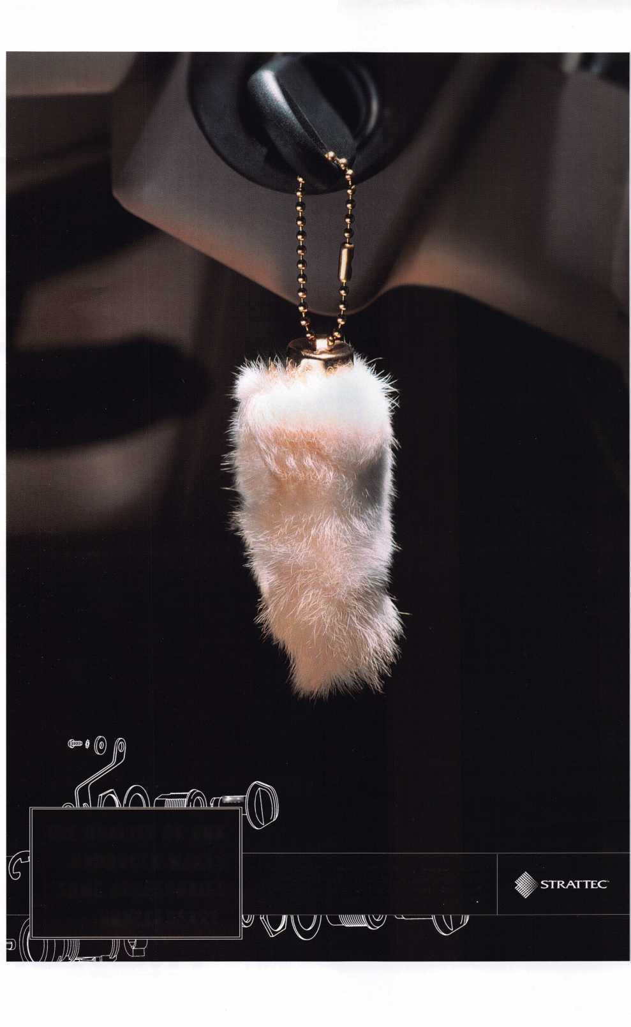

**Unlocking**

**Ford/Mazda**

**Transponder**

Css***9^mk.mWj^t^***

**You're never on your own..**

**Toll Free Tech Support**

**1**-**800**-**342-5080**

vv

I've lost my Taurus keys...

can you make a new set?

+■

if

How much of your money  
have you sent to the  
local Ford dealer?

/>*

%

8008LA New Generation STAR

Use the Ford factory tool to  
program transponder keys for  
ALL Ford/Mazda vehicles.

Keep the money in your pocket!

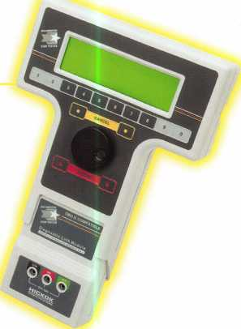

NGS

Complete

Ford/Mazda

transponder

coverage

PLUS the

ability to clear ALL

Diagnostic

Service Codes

Say "YES" to  
$100 phone calls



HICKOK

